 **DEPARTMENT OF PHYSICAL EDUCATION**

**Korambayil Ahamed Haji Memorial**

**UNITY WOMEN’S COLLEGE, MANJERI**

# 

# ANNUAL REPORT 2021 -’22

**The college Netball team Participated in the Malappuram District Netball Championship held at Marthoma College Chungathara on 13th October 2021**.

College **Netball** team participated in the Malappuram District Championship held at Marthoma College Chungathara on 13th October 2021. Team got **THIRD** place.

**Team Members:**

1. Sundus, III Year BA English (Captain).
2. Anshiba K, III Year BA History.
3. Sherin, III Year B Sc Chemistry.
4. Hiba Sherin, II Year Computer Science..
5. Febna, III Year BA History.
6. Shyma, III Year Botany.
7. Nasreen K, III Year B Sc Maths.
8. Najwa, II Year BA History.
9. Athira P, III Year Botany.

**The department Conducted Interdepartment Badminton (Shuttle) “WINNING SMASH” from 22nd to 24th November 2021**.

**Results:**

First : Nishana Sherin C & Farseena P, P G Department of Computer Science.

Second: Anan M C & Shehar Banu, Department of History.

Third: Hridya & Diya, Department of Home Science.

**The department Conducted “SHE KICK” on 10th December 2021**.

Manager Eng. O. Abdul Ali Inaugurated the function. Staff and students enthusiastically participated in the meet and made it a grand success. Also give prizes for the ones who scored goal.

**The Ball Badminton team Participated in Ball Badminton (Shuttle) in the Inter-Collegiate (Inter-zone) Championship held at Carmel College, Mala on 3rd January 2022**

College **Ball Badminton (Shuttle)** team participated in the Inter-Collegiate (Inter-zone) Championship held at Carmel College, Mala on 3rd January 2022.

**Team Members:**

1. Nishana Sherin C, III B.Sc Computer Science (Captain).
2. Anan M C, III BA History.
3. Fathima Diya, II B.Com CA.
4. Huda Nureen C, I B Sc Computer Science.
5. Ajna K.P, II B.Com Co-operation.
6. Jamsheena Odakkal, II B.Com CA.
7. Shahla K, I BSc FCS.
8. Rasha Mariyam M, I BSc FCS.
9. Rashika Parveen, I B Sc Computer Science
10. Farseena P. III B.Sc Computer Science.

**The department Conducted T M Shoukathali Memmorial Inter-College Badminton for staff on 25th January 2022**

**Results:** **(Men)**

First: Sullamussalam arts and science college, Areekode.

Second: KAHM Unity Women’s College, Manjeri.

Third: MES Mampad College.

**(Women)**

First: KAHM Unity Women’s College, Manjeri.

Second: MES Mampad College.

Third:Malabar College of advance studies, Vengara.

**The department Conducted “FOOTBALL EXHIBITION MATCH” on 21st February 2022**

A football exhibition match between FC Areekode and SOHSS Areekode under 14 team conducted at college ground. Match won by FC Areekode by the score (2-0).

**The department Conducted Intramurals in Badminton (Shuttle) from 21st to 22nd March 2022**.

**Results:**

First : Nishana Sherin C, III B.Sc C S & Huda Nowreen C, I B.Sc C S Mouryans House. Second: Anan M C, III BA History & Sabna, III BA History, Gupta House.

Third : Diya, II B.Sc FCS & Hridya, II B.Sc FCS, Kalinga.

**The department Conducted Intramurals in Football from 21st March to 24th March 2022**.

In the First match Guptha House defeated Mouryans House.

In the second match Mugals House defeated Kalinga House

In the Losers final Mouryans House defeated Kalinga House and got Third Place. In the Finals Guptha House defeated Mugals House and become the champions.

**Results**

**I** Guptha House.

**II** Mugals House**.**

**III** Mouryans House.

**The department Conducted 27th College Annual Athletic Meet “ZUSAMMEN 2K22” on 23rd march 2022**.

Staff and students enthusiastically participated in the meet and made it a grand success. **Guptha** House became the **Champions**. **Ms. Rashika Parveen**, I Year B.Sc. Computer Science of Mouryans House is the Individual champion by bagging **23** points.

**Students Representation**

|  |  |  |  |  |
| --- | --- | --- | --- | --- |
| Sl. No. | Name | Class | Event | Level |
| 1 | Najwa | II Year B A History | Netball (Sr) | Malappuram District |
| 2 | Nasreen K | III Year B Sc Maths | Netball (Sr) | Malappuram District |

**Malappuram District Netball Championship held at Marthoma College Chungathara on 13th October 2021**.

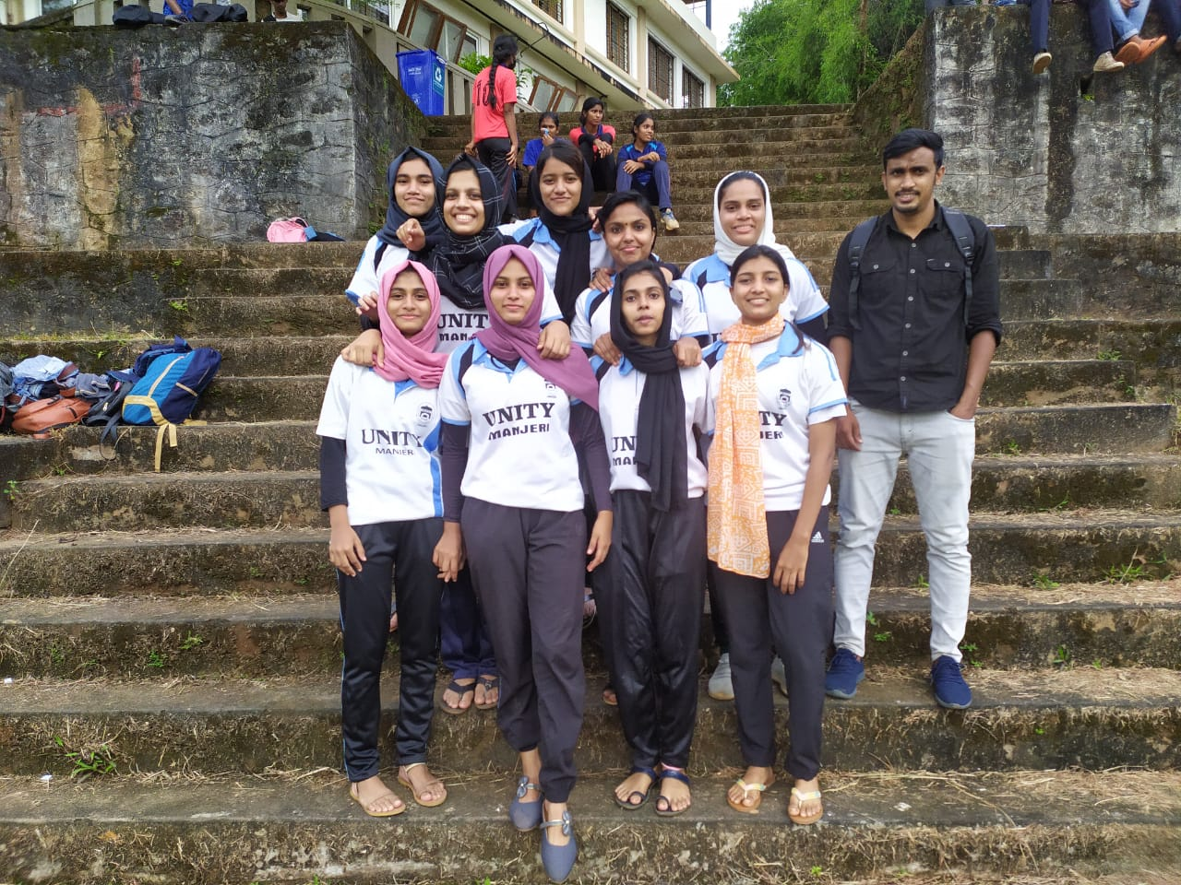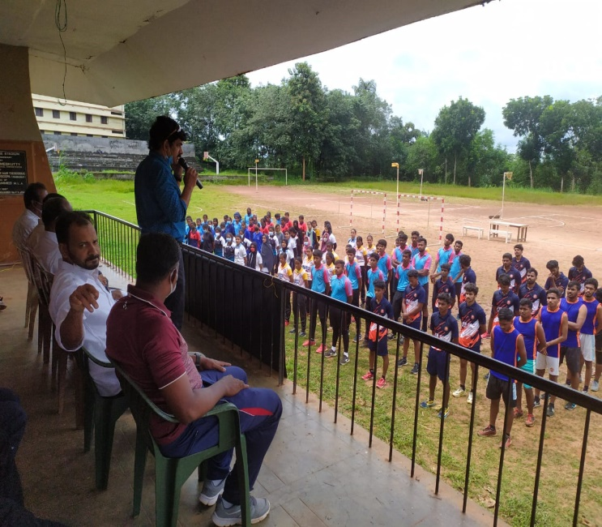

**Interdepartment Badminton (Shuttle) “WINNING SMASH” from 22nd to 24th November 2021**.

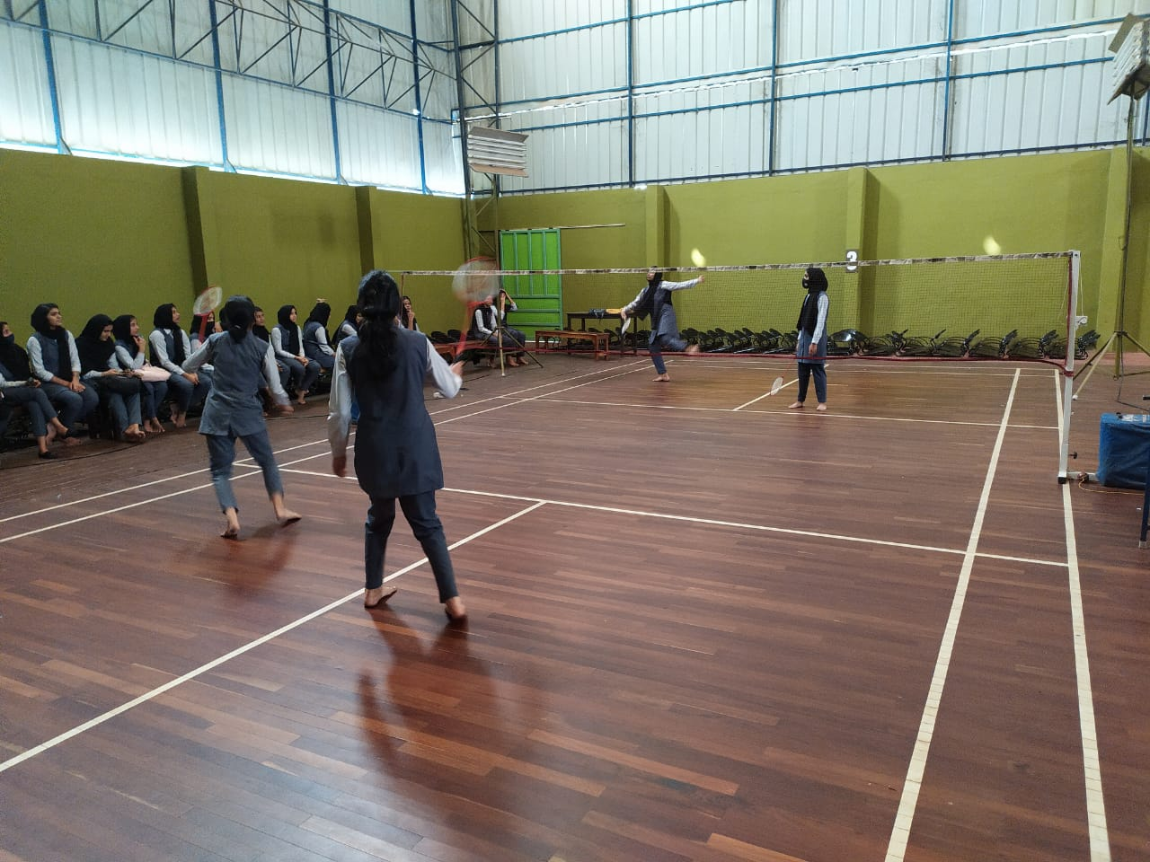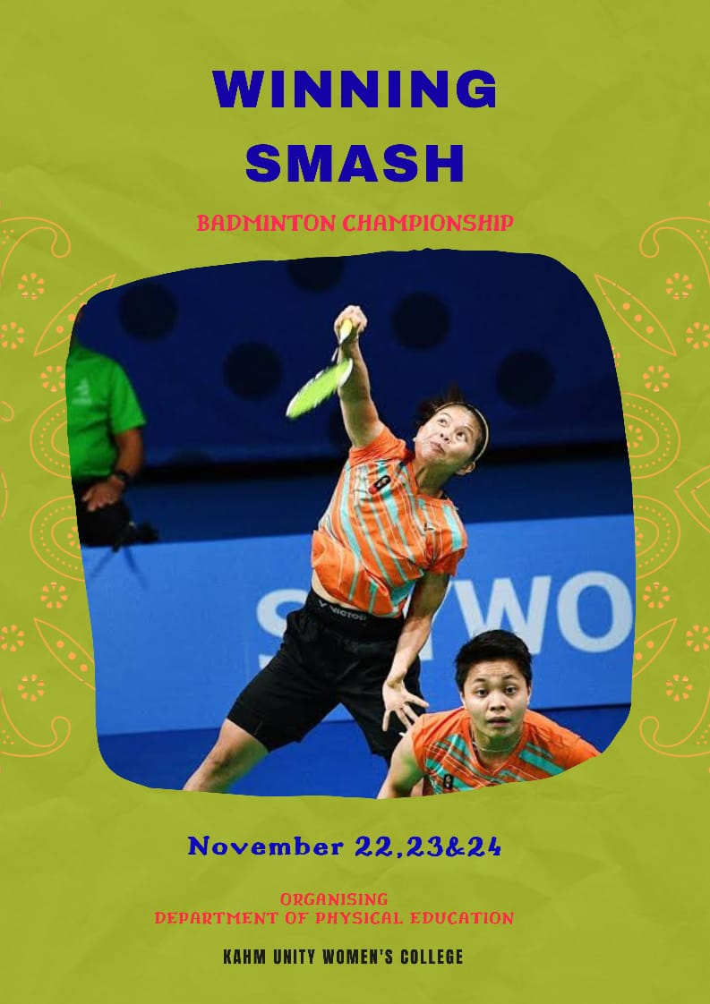

**“SHE KICK” on 10th December 2021**.

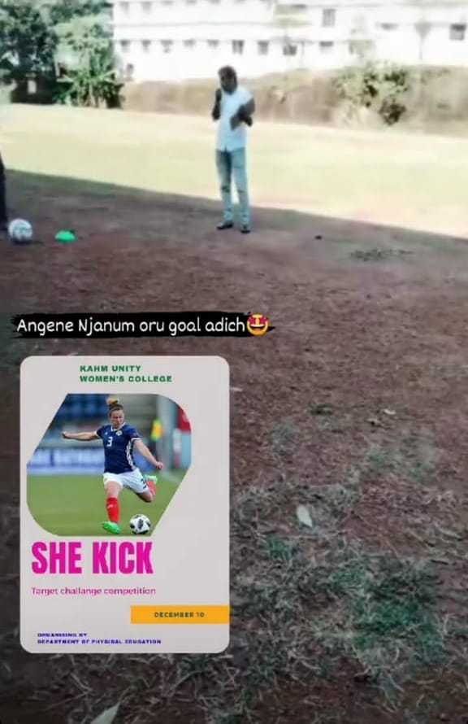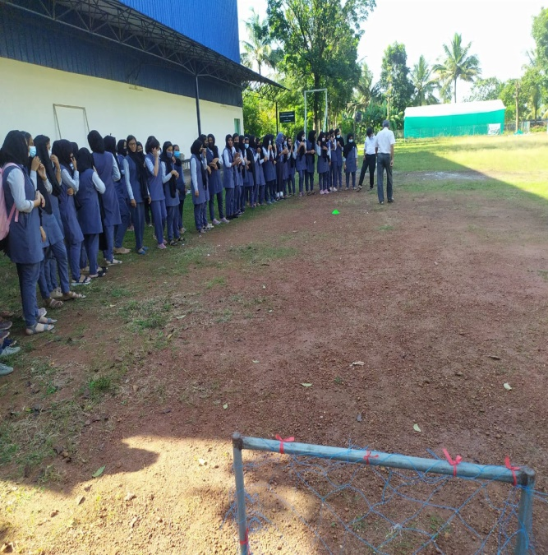

**Ball Badminton (Shuttle) Inter-Collegiate (Inter-zone) Championship held at Carmel College, Mala on 3rd January 2022**

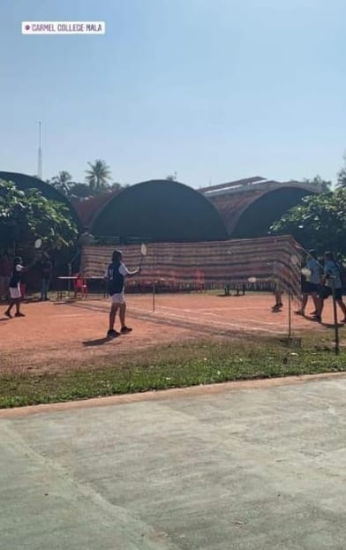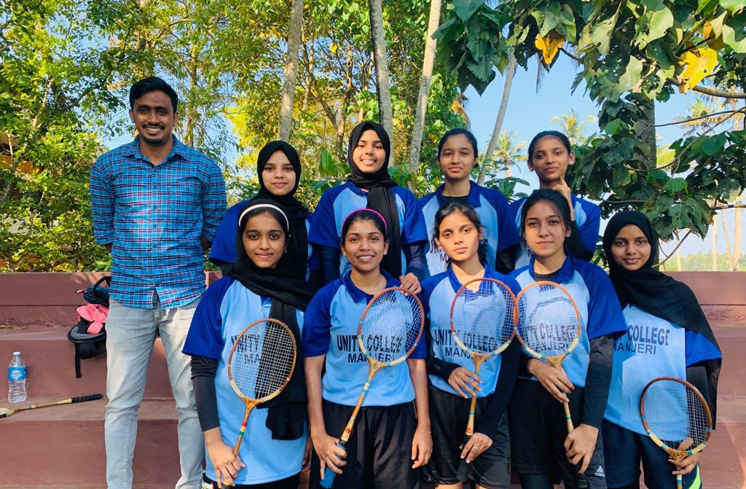

**T M Shoukathali Memmorial Inter-College Badminton for staff on 25th January 2022**

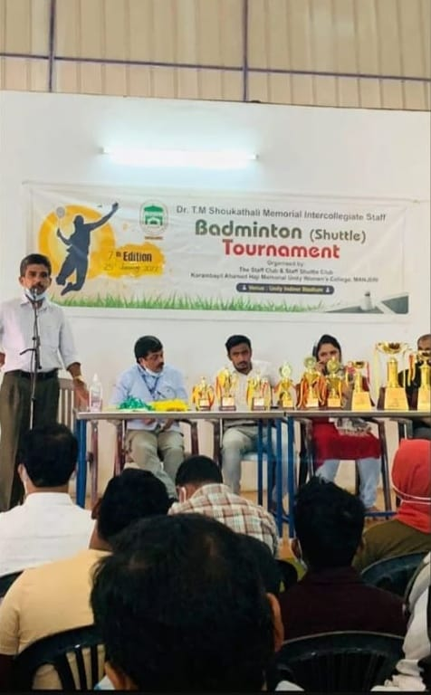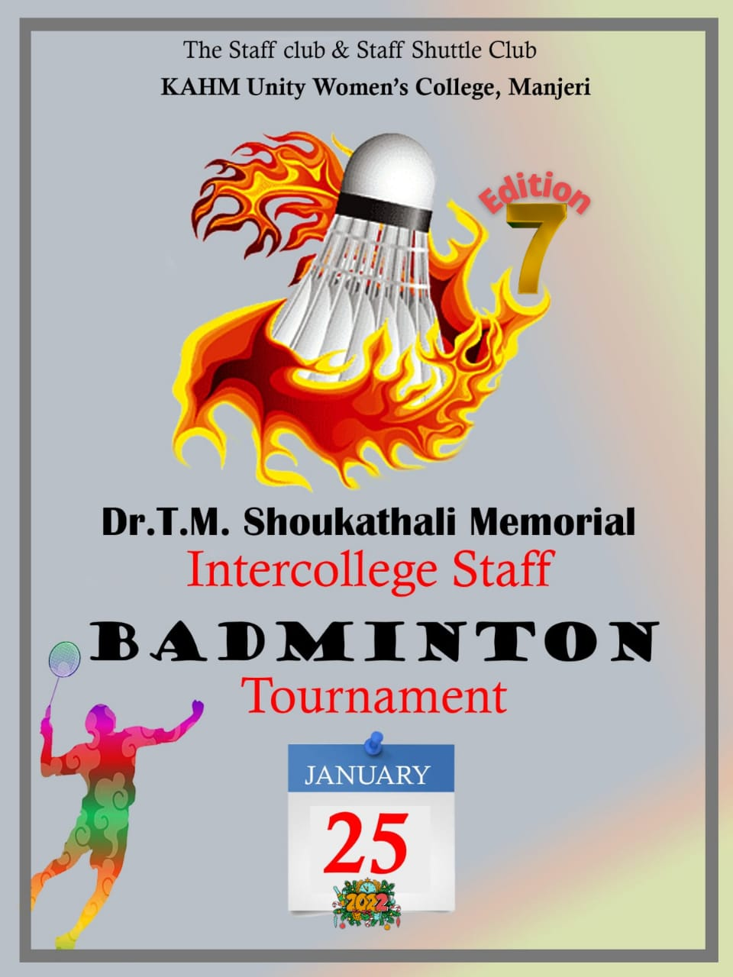  
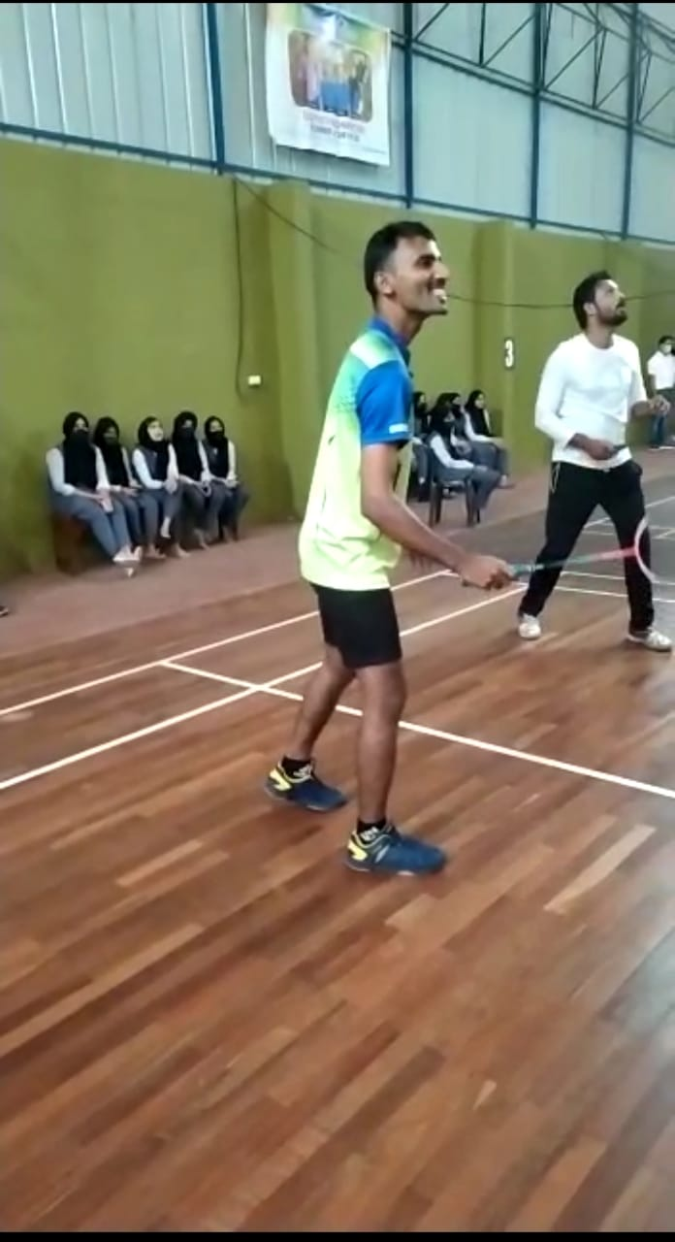

**“FOOTBALL EXHIBITION MATCH” on 21st February 2022**

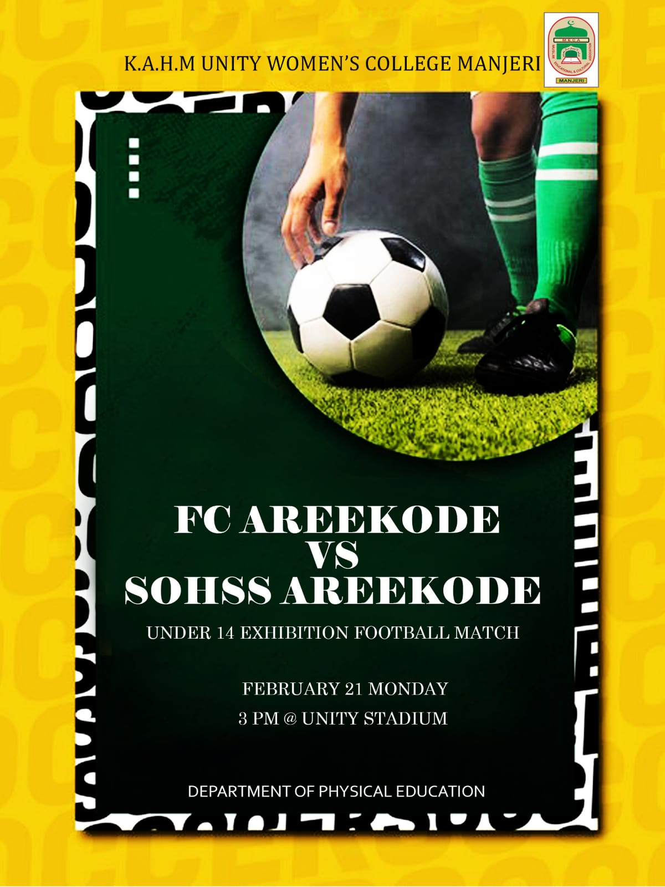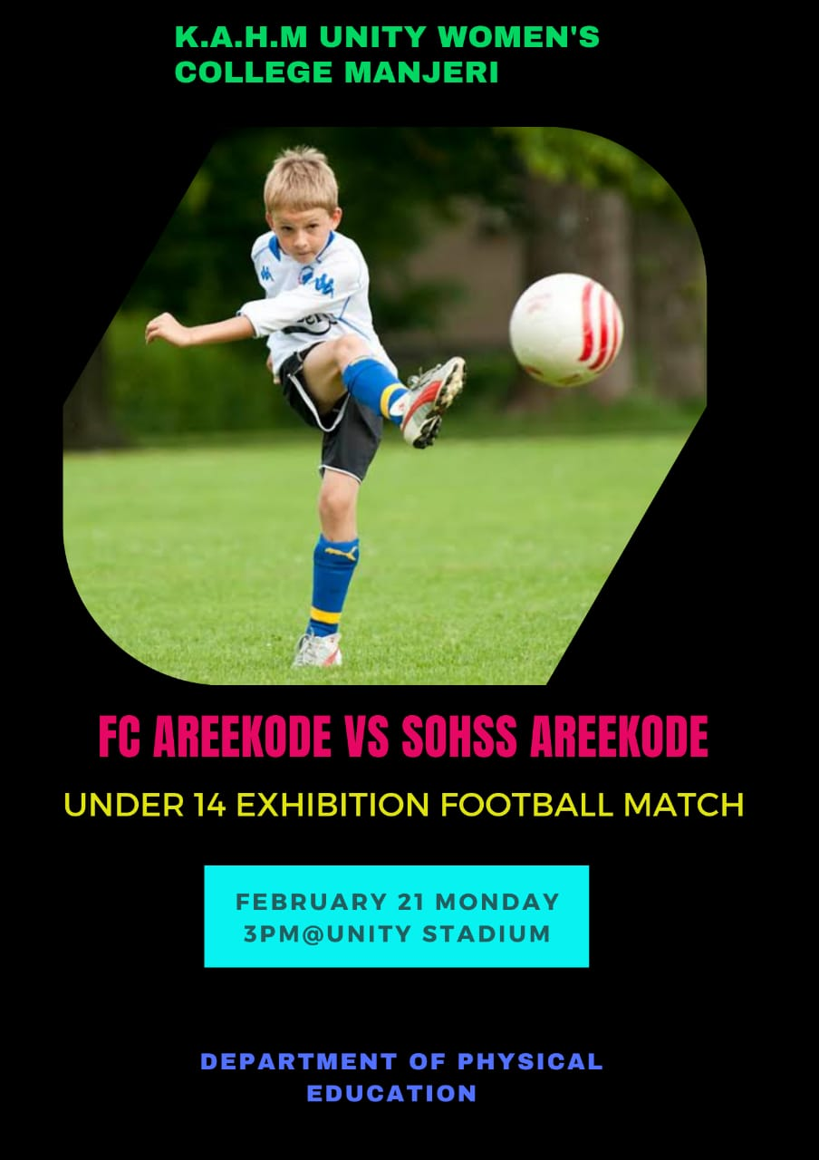

**Intramurals in Badminton (Shuttle) from 21st to 22nd March 2022**

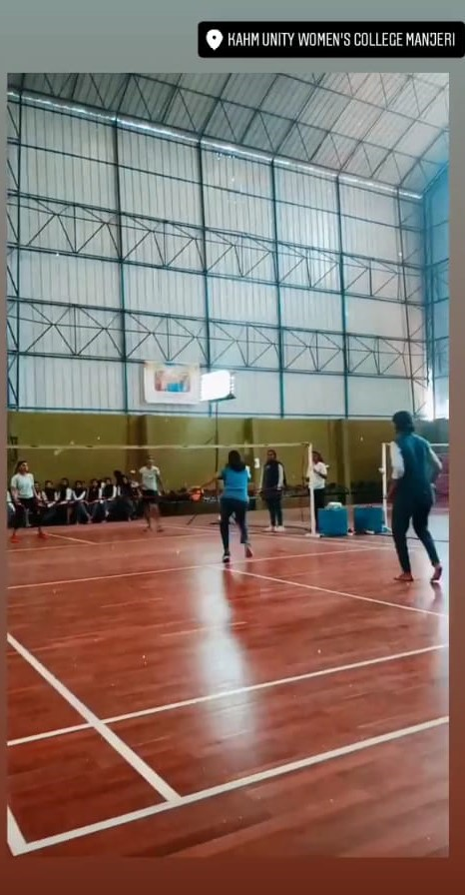 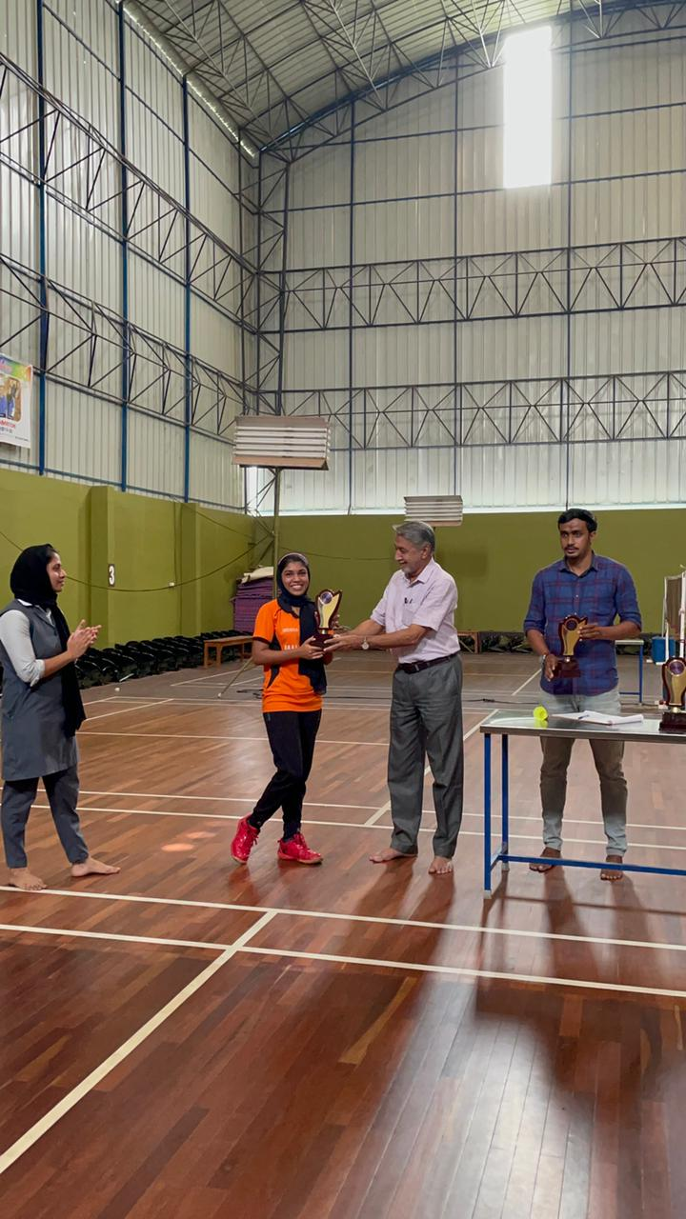

**Intramurals in Football from 21st March to 24th March 2022**.

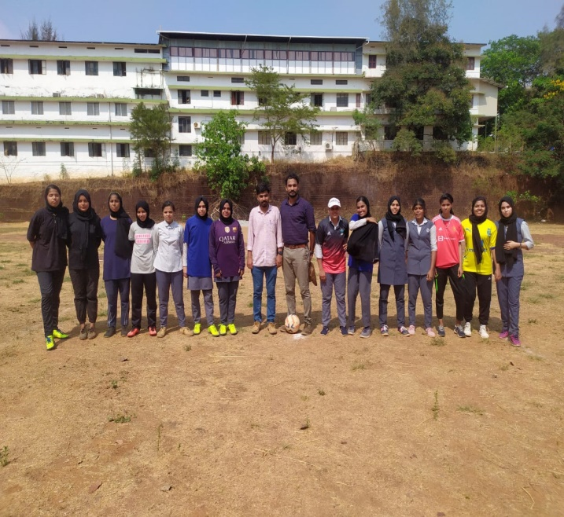 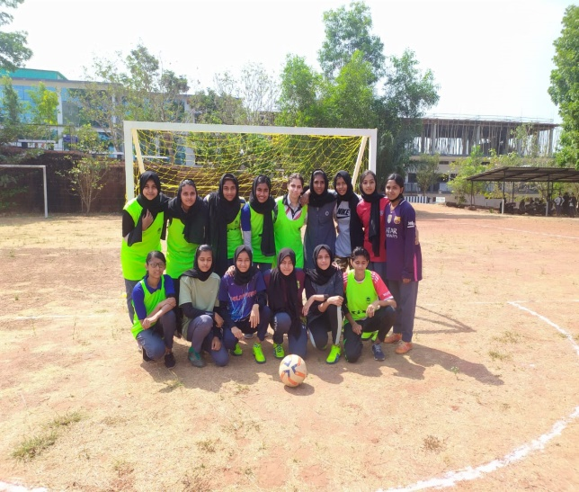

<https://m.facebook.com/groups/KAHMUWCALUMNI/permalink/5008423612584388/?mibextid=Nif5oz>

**27th College Annual Athletic Meet “ZUSAMMEN 2K22” on 23rd march 2022**.



