Activities 2021-22

Environmental Day Celebration
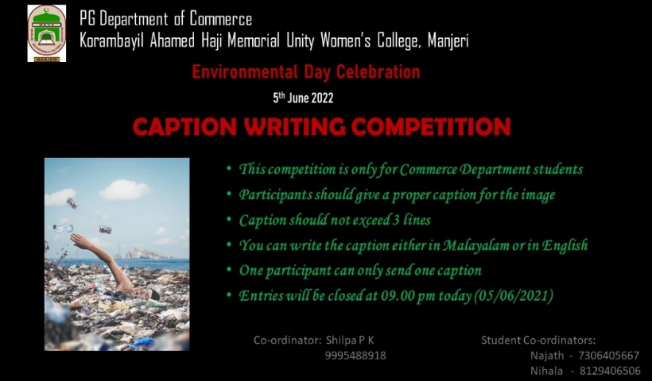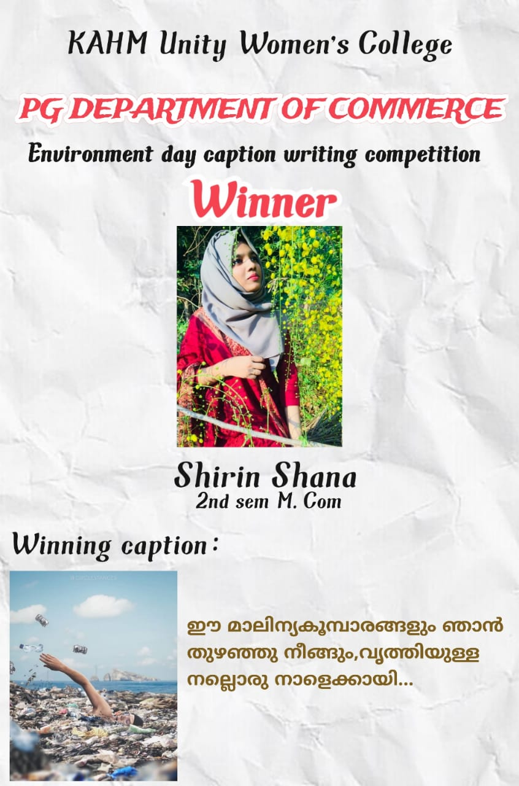
Environmental Day celebrated on June 5th with “Caption Writing Competition” under the aegis of Commerce Association. 30 students participated in the competition. Mrs. Shirin Shana from Second Semester M.Com has been declared as the winner.

Career Opportunities in Commerce
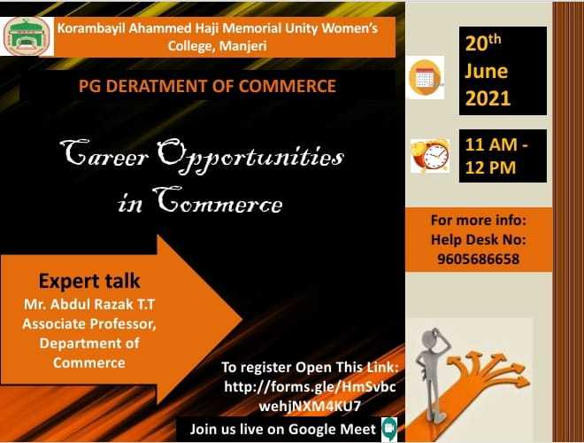
A Session was arranged for the Second year and final year students about Career Opportunities in Commerce on 20th June 2021. Mr. Abdul Razak, Head & Associate Professor, PG Department of Commerce, KAHM Unity Women’s College was the speaker.

Transforming Ideas into Successful Business Ventures
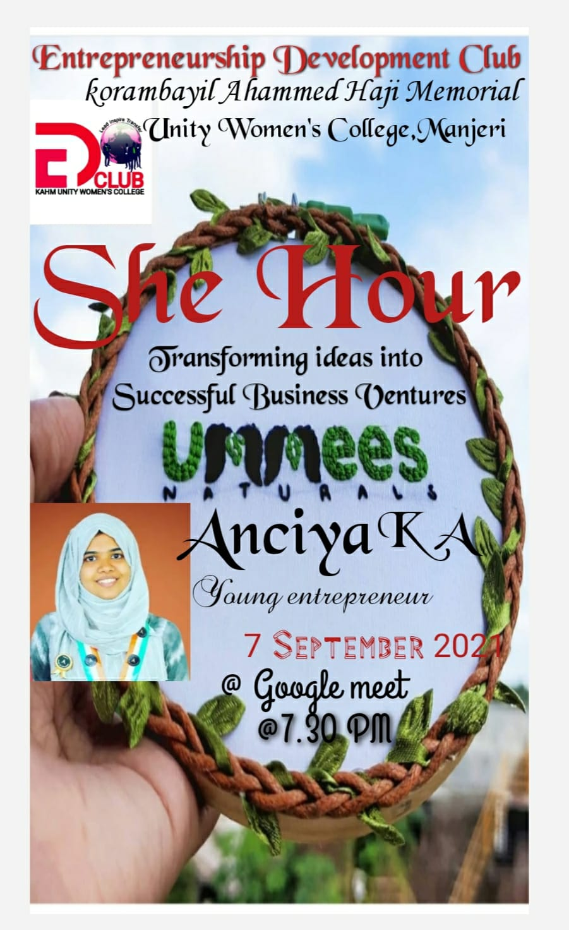

Transforming Ideas into Successful Business Ventures – An interactive online session was arranged on 7th September 2021 under the ED club with Anciya K A, young entrepreneur and the owner of Ummees Naturals.

Industrial Visit
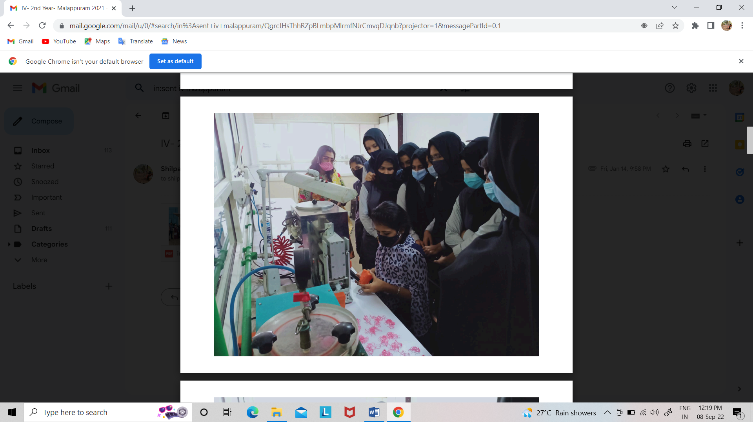
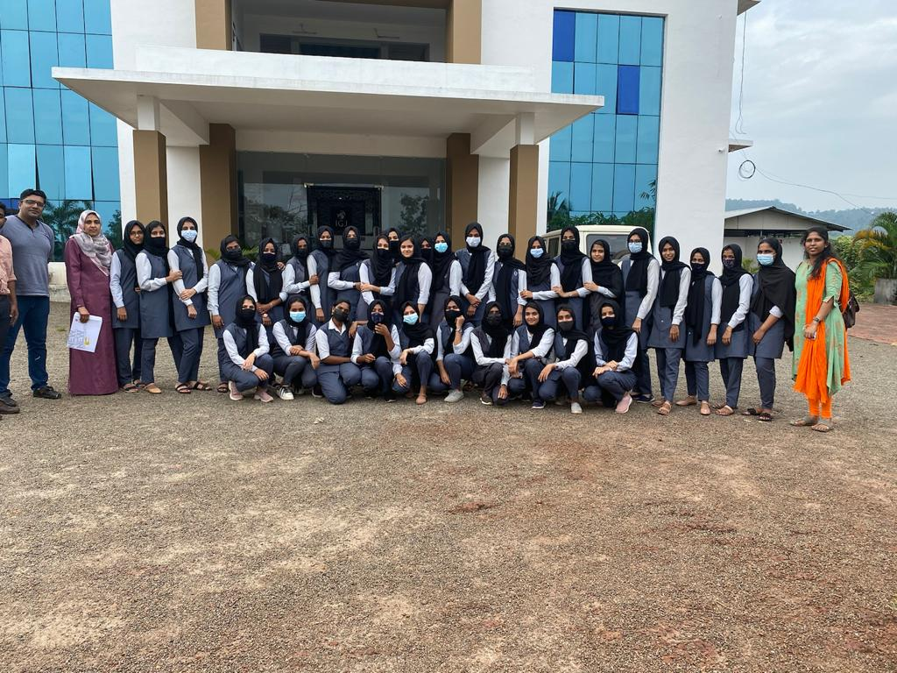
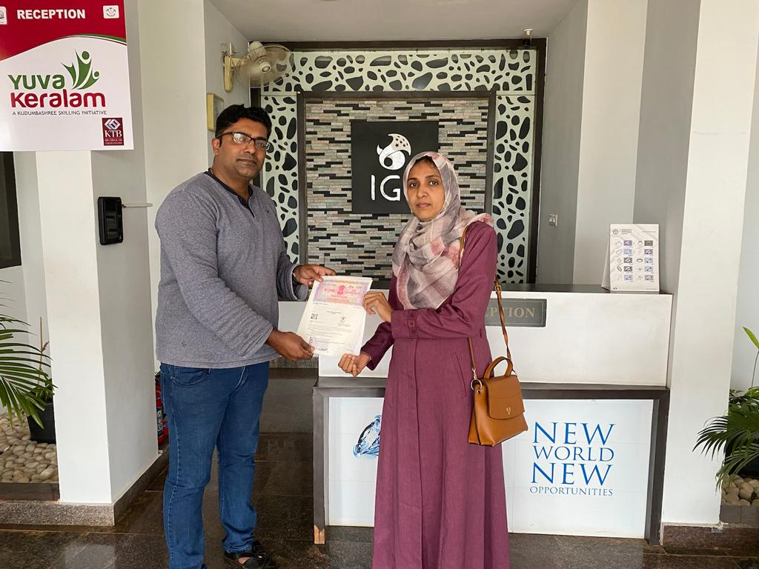

Arranged an Industrial Visit to Institute of Gems & Jewellery, Malappuram on 27th November 2021. 31 students took part in the visit.

Workshop on Photo Framing
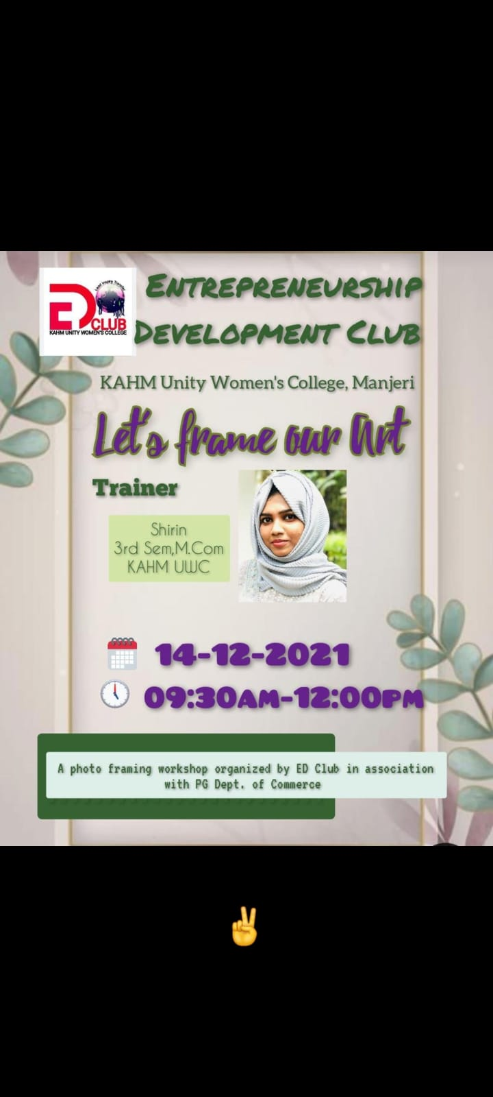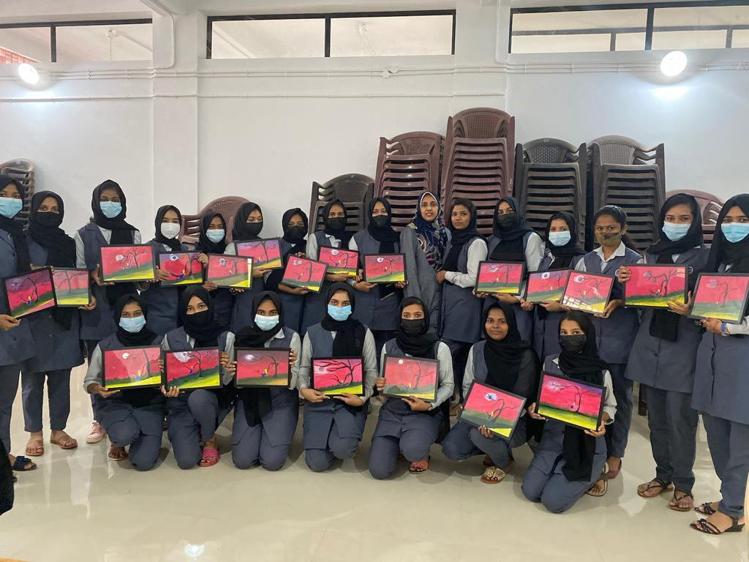
Conducted a workshop on Photo framing “Let’s frame our Art” on 14th December 2021under the ED club. Mrs Shirin Shana,Third Sem MCom was the trainer - 30 students attended the programme.

Industrial Visit
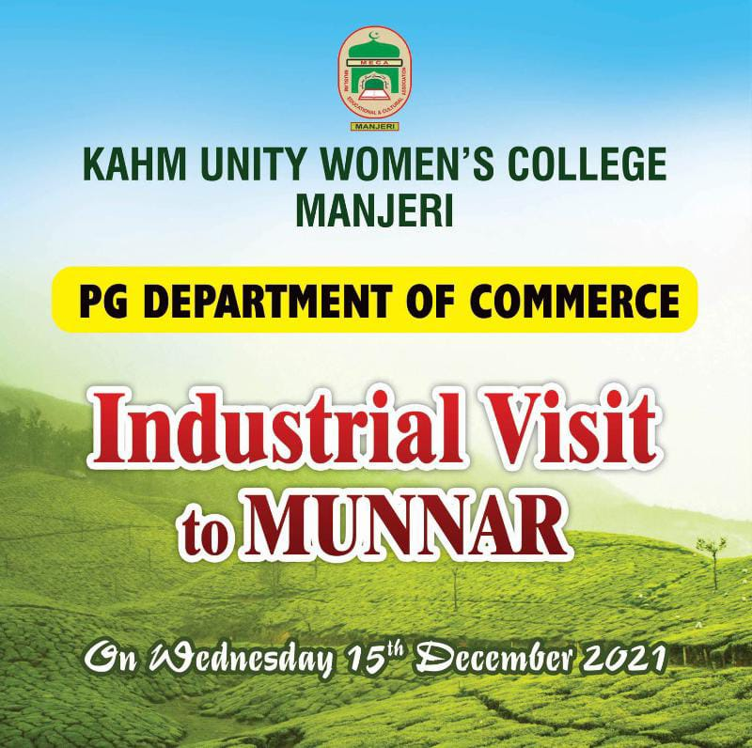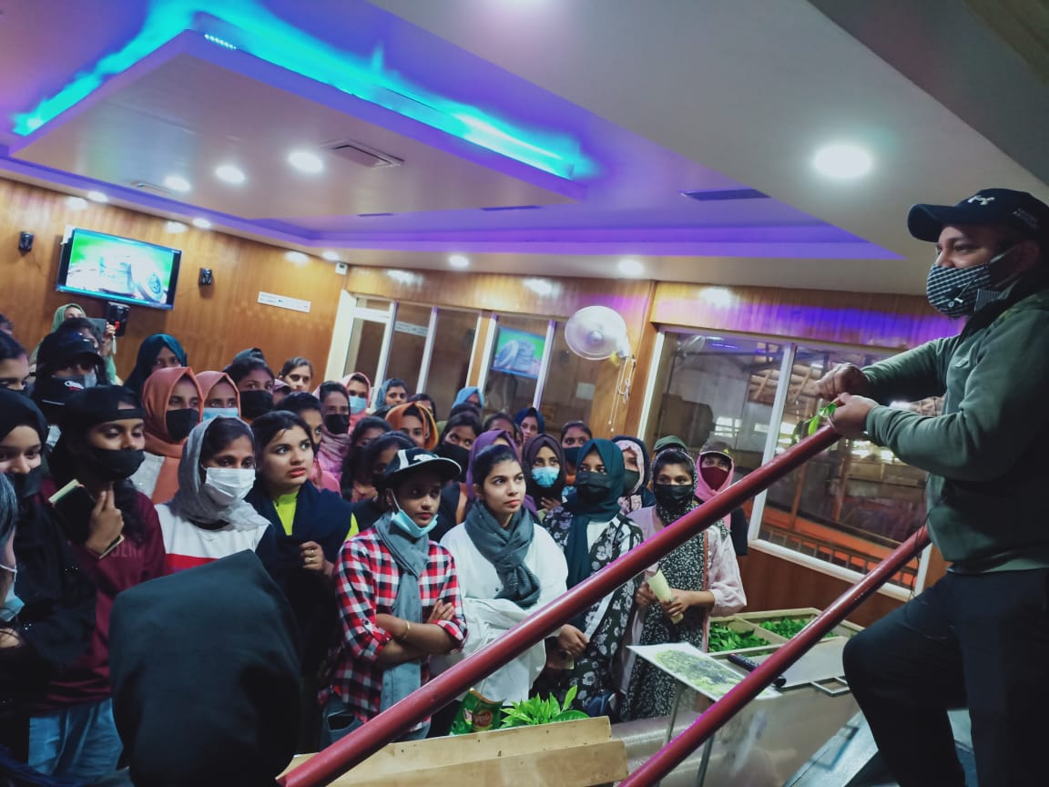
A two-day Industrial Visit was organized to Munnar Ripple Tea Factory on 15th December 2021. 55 final year students took part in the visit.

Workshop on Research Methodology
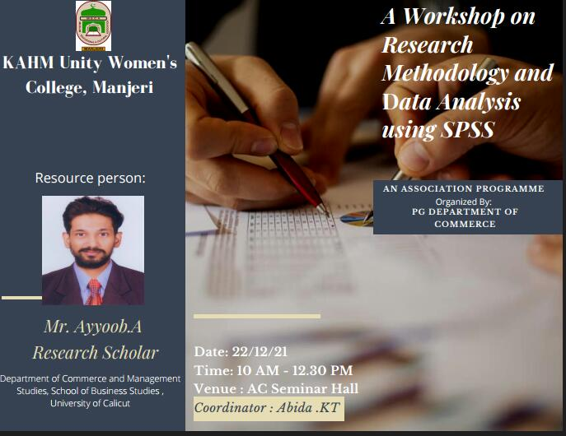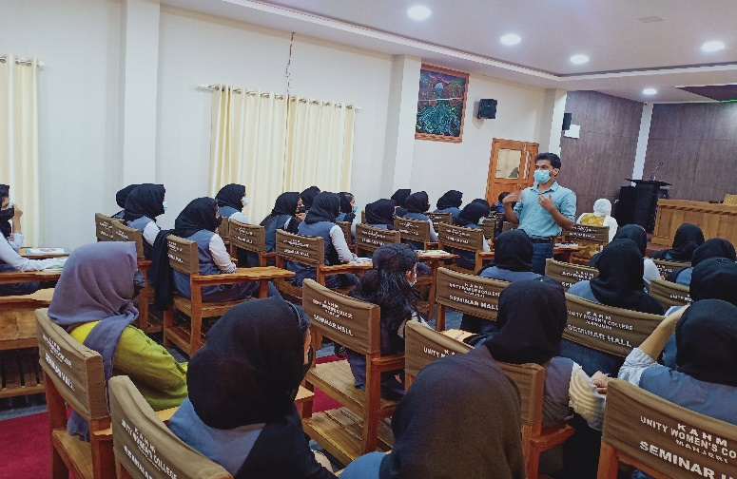
Organised a workshop on Research Methodology and Data Analysis using SPSS on 22th December 2021. Mr. Ayyoob, Research Scholar, DCMS was the resource person - 100 students participated.

Consumer Rights Day Celebration
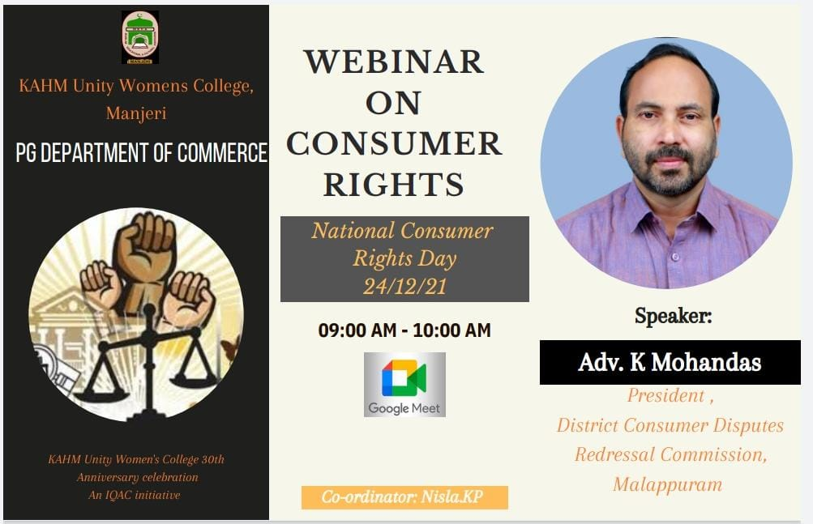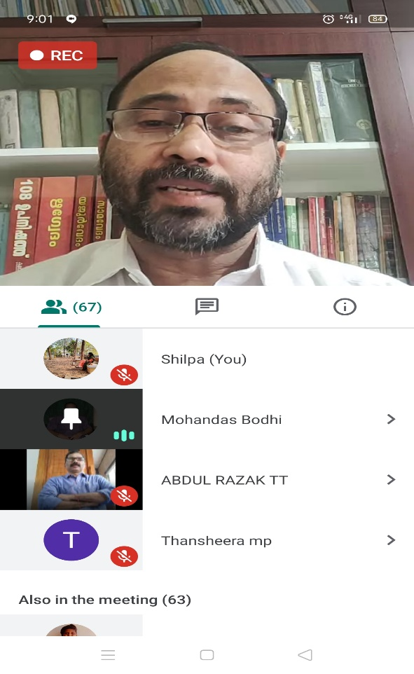
A webinar was organized on 24th December 2021 to celebrate Consumer Rights Day. Adv. K. Mohandas, President, District Consumer Dispute Redressal Commission, Malappuram was the speaker. 100 students participated.

Field Visit
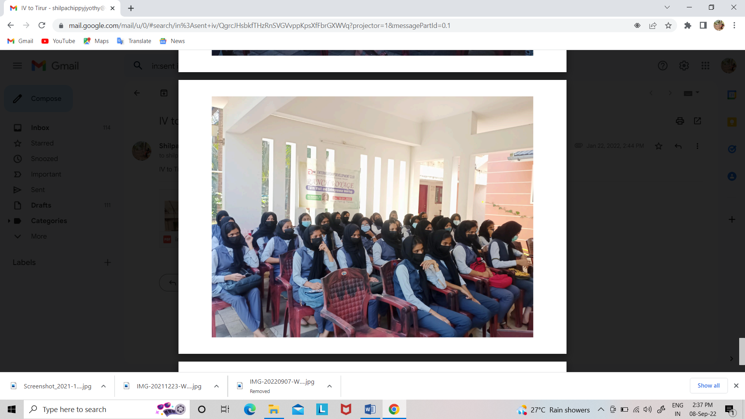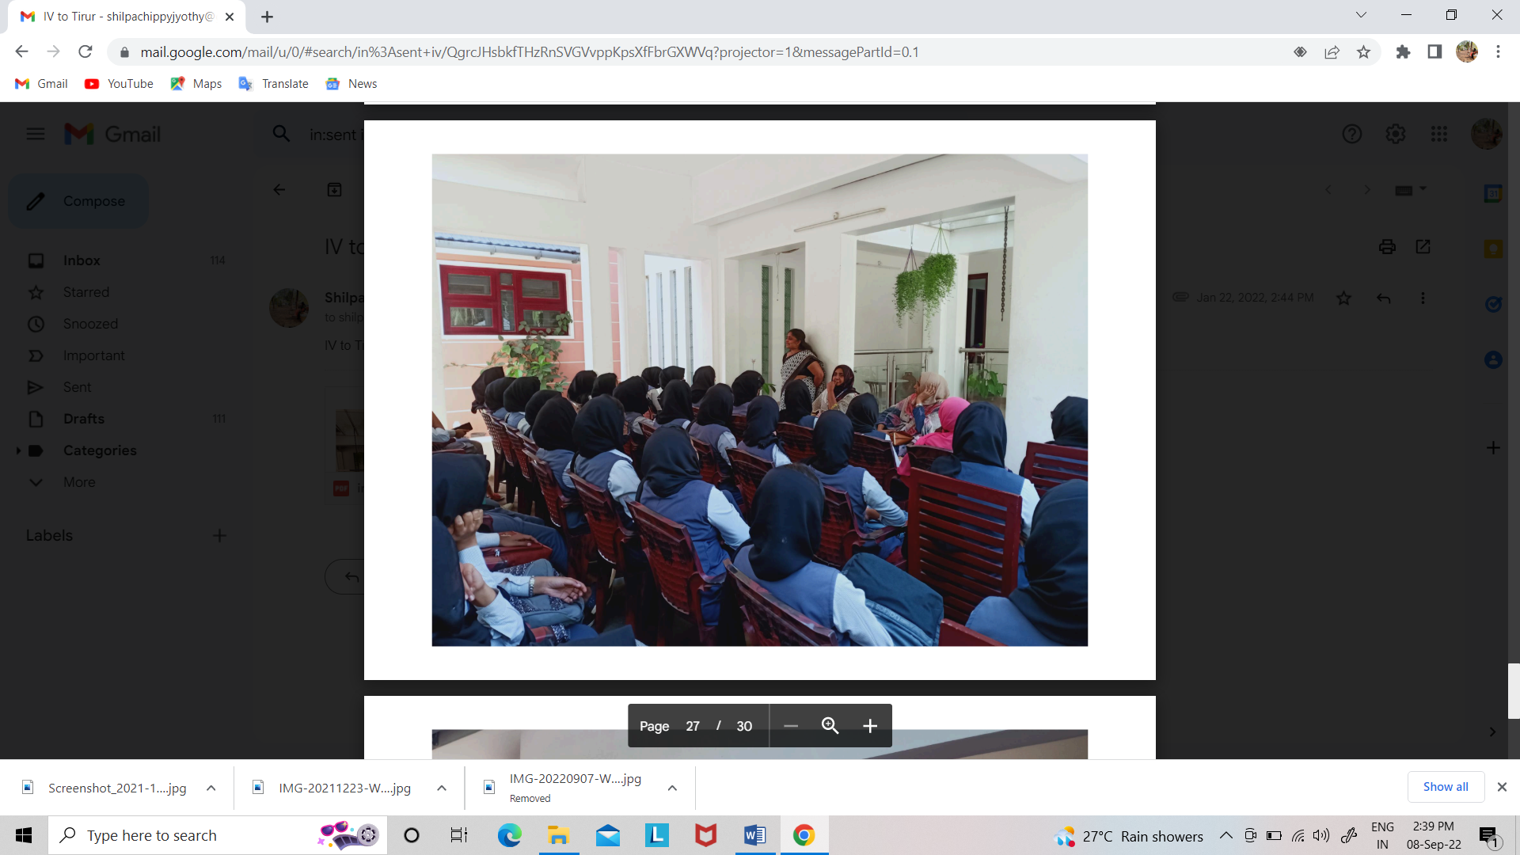
Organized an Interactive Session and Field Visit by the ED club on 15th January 2022 with Sushama P.T, Agro entrepreneur from Tanalur, Tirur

Investor Awareness Program
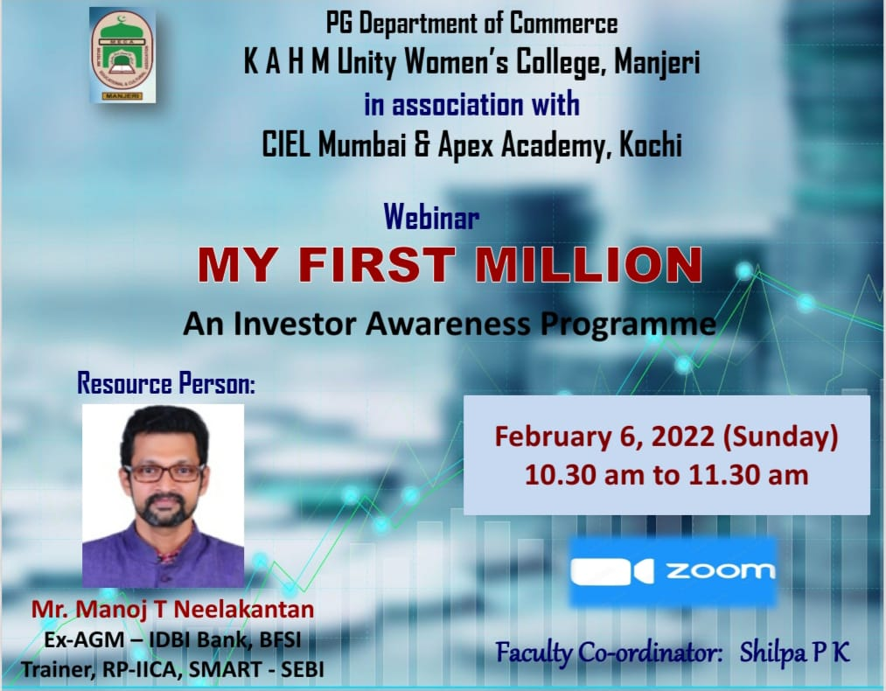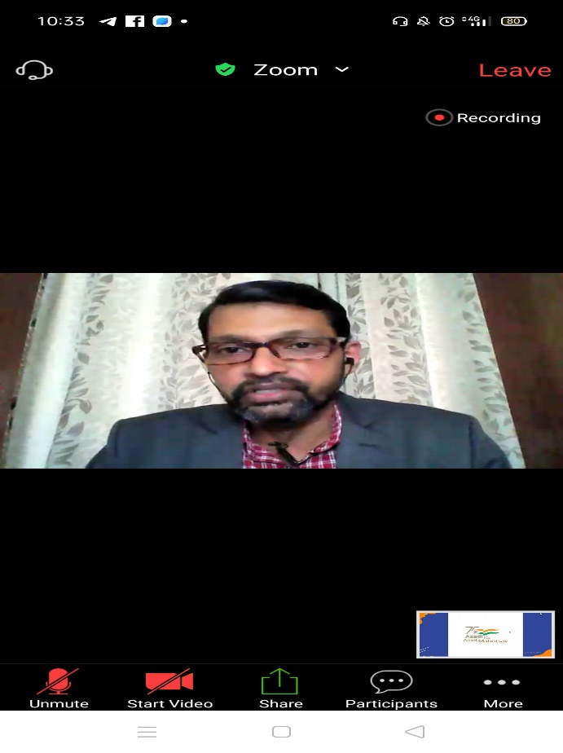
An Investor Awareness Program “My First Million” was conducted online in association with CIEL Mumbai & Apex Academy Kochi on 6th February 2022. Mr. Manoj.T. Neelakantan, Ex-AGM, IDBI Bank and SEBI trainor, was the speaker.

Career Opportunities in Current Market Scenario
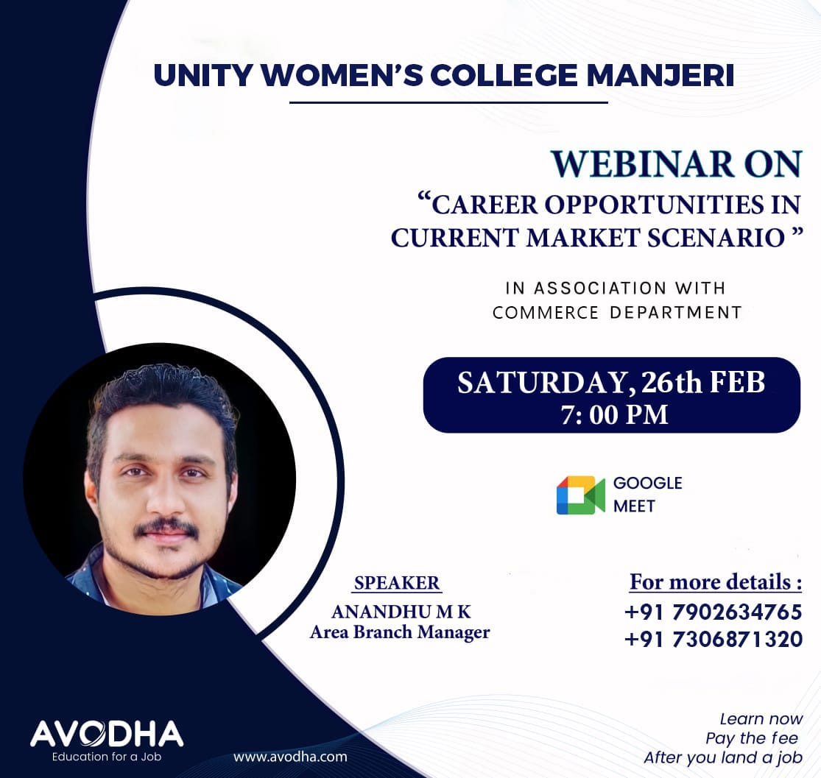
A Webinar on “Career Opportunities in Current Market Scenario” was organized by the dept in association with Avodha EduTech on 26th February 2022. Mr Anandhu M, Area Branch Manager, Avodha was the resourse person.

Career Opportunities
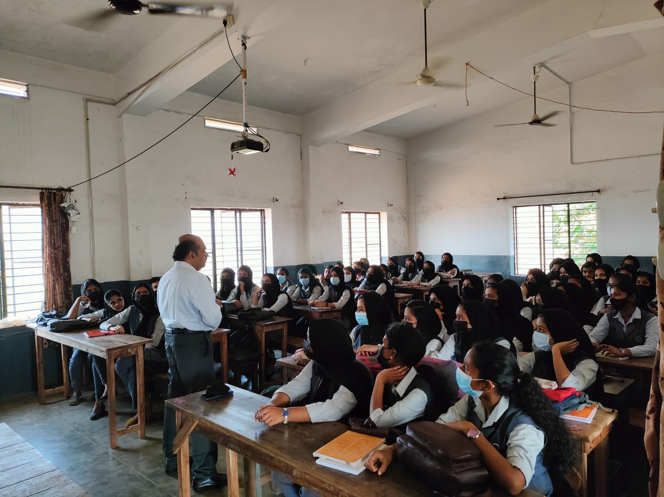
A Session was arranged for the First Year Students about Career Opportunities on 10th March 2022. Mr. Balachandran, Vidyarupa, Cochin was the speaker.

Annual Day and Farewell to seniors 22
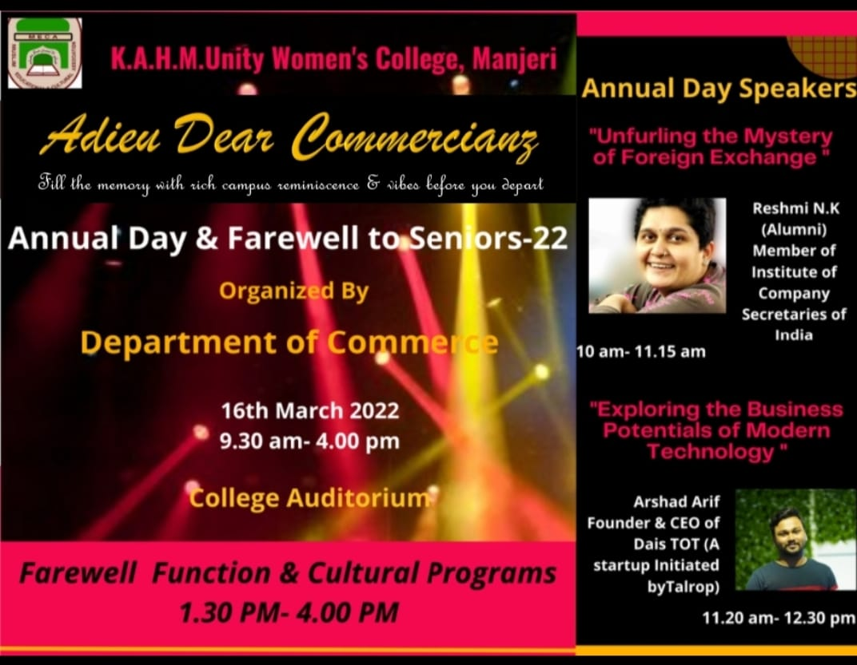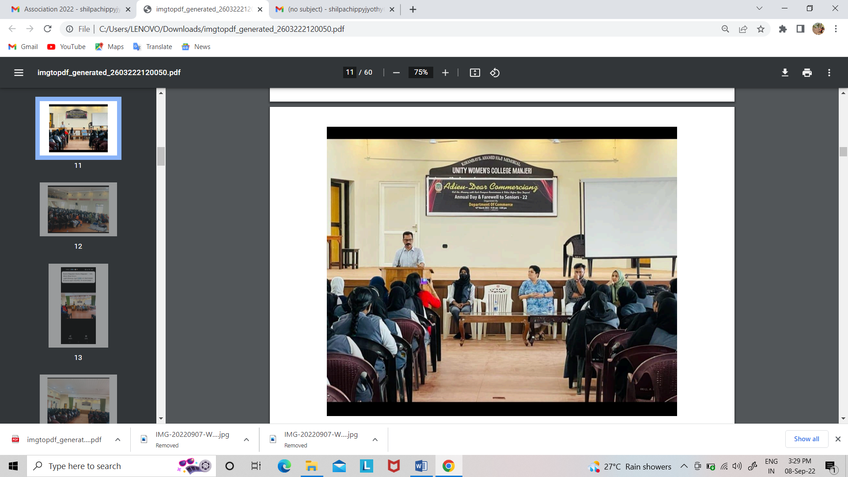
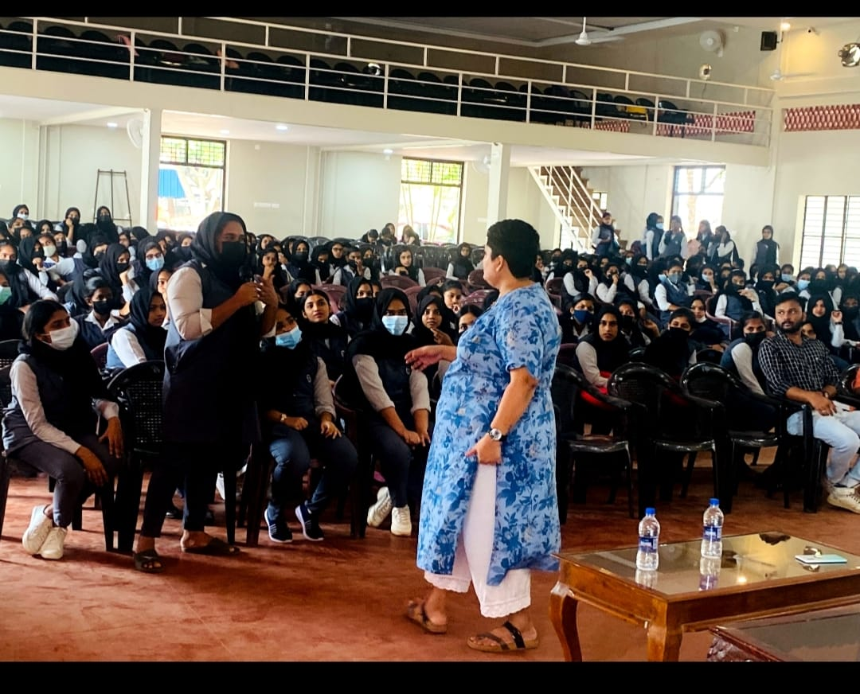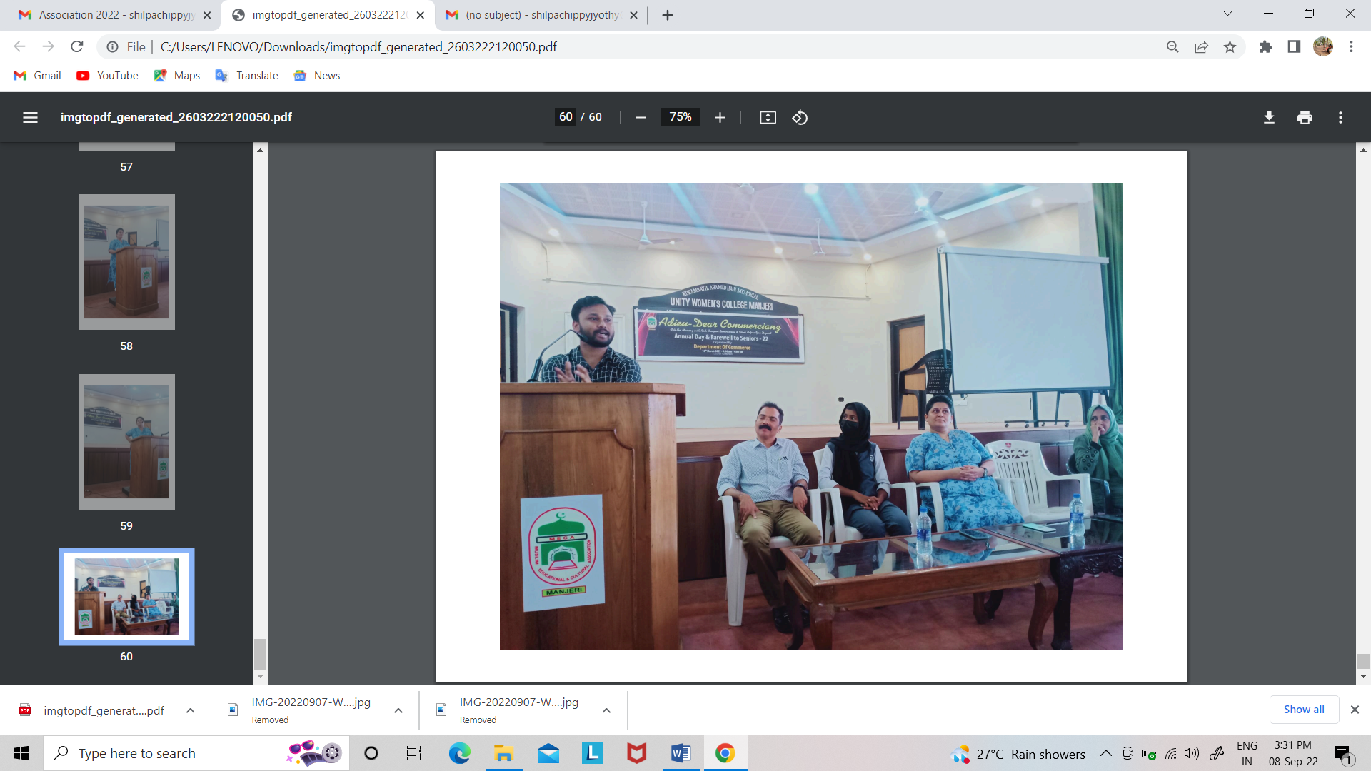
Annual Day and Farewell to Seniors 22 was organized on 16th March 2022. Resmi N.K (Company Secretary and Alumni of the dept) handled a class on “Unfurling the Mystery of Foreign Exchange”. Second session was handled by Arshad Arif (Founder & CEO of Dais TOT) on “Exploring the Business Potentials of Modern Technology”. A grand farewell to the senior students was also took place with cultural programmes in the afternoon.

Community Outreach Programme
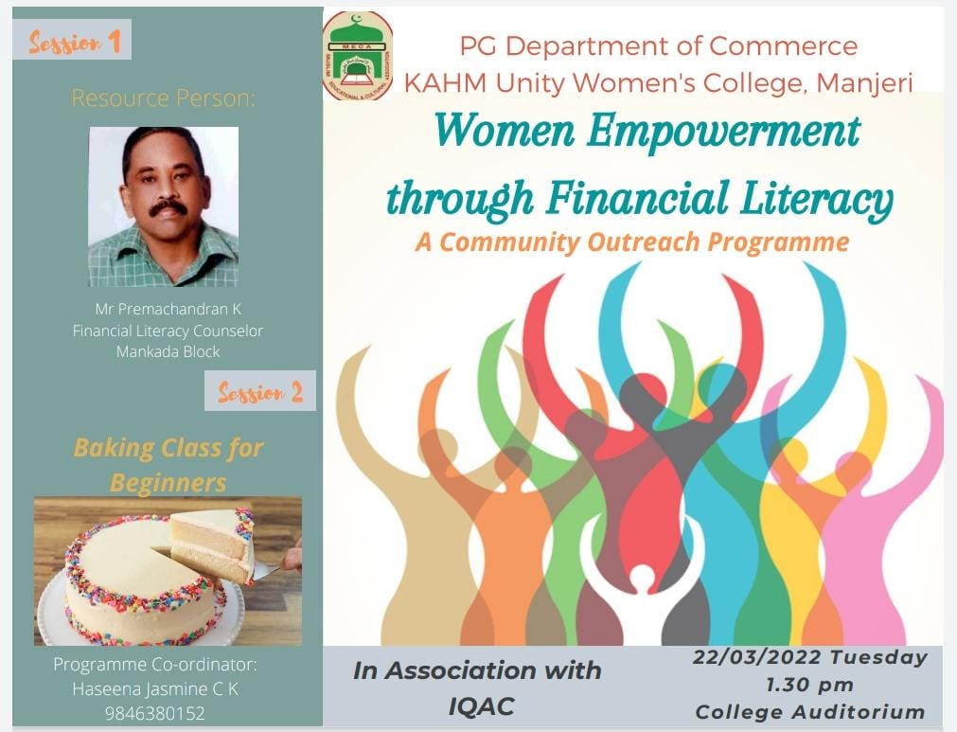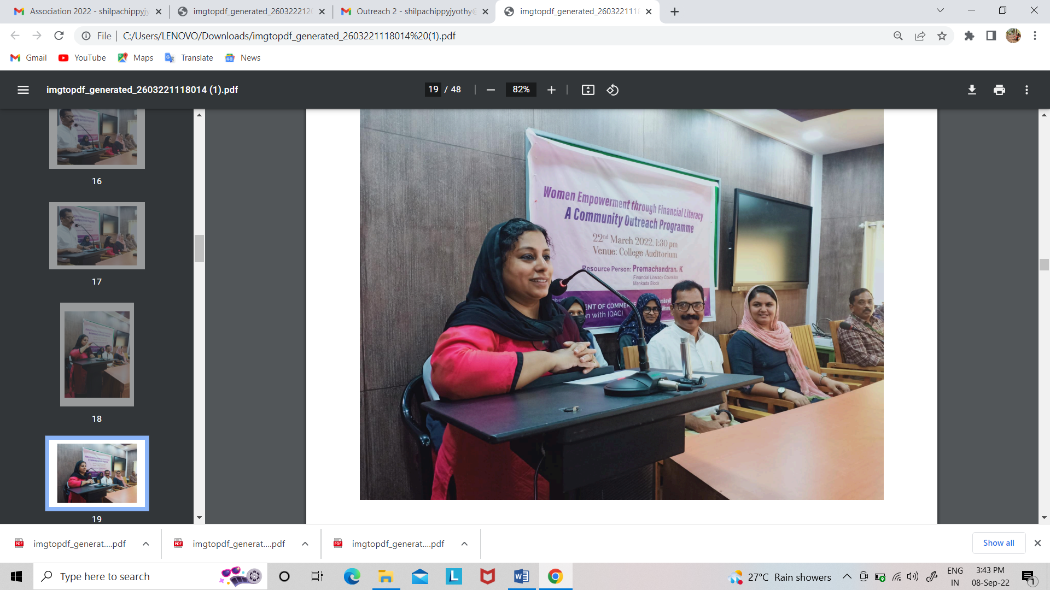
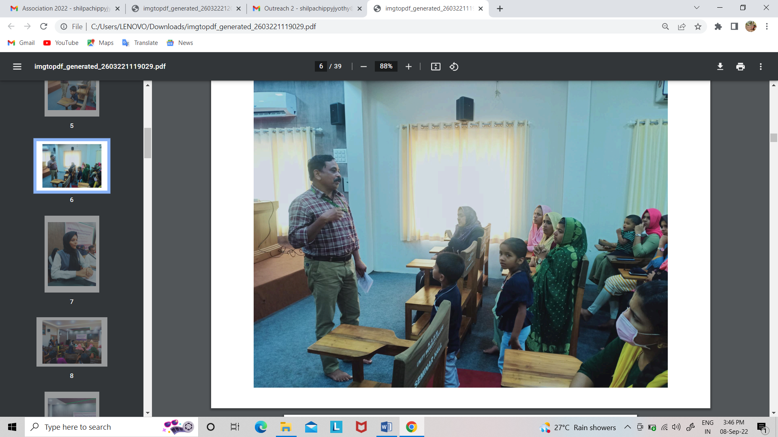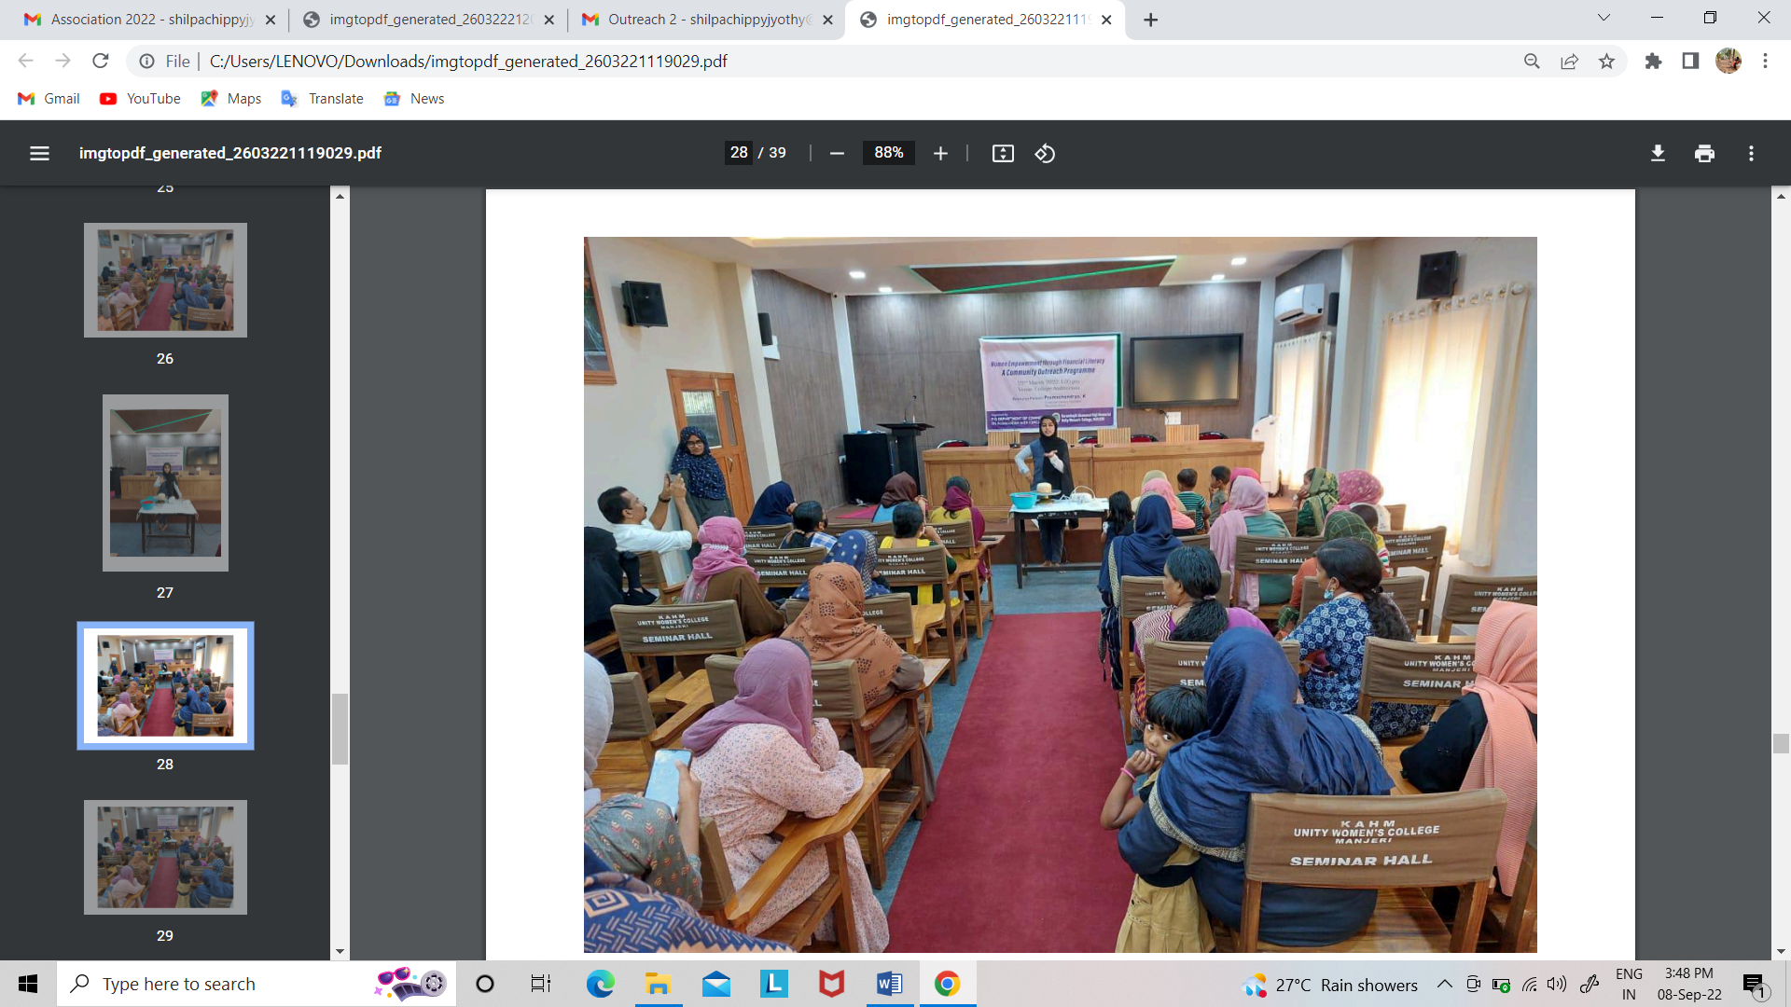
Conducted a Community Outreach Programme on 22nd March 2022under the title “Women Empowerment through Financial Literacy”. A cake demonstration was also arranged for the participants at the end of the session. 50 women from neighboring places attended. Premachandran.K (Financial Literacy Counselor, Mankada Block) was the resource person.

