**DEPARTMENT EVENTS 021-22**

**Activities under the Research Club, P G Department of English**

The Research Club has organized an Online Project Management Workshop for Degree and PG students of English Language and Literature on 16 August 2021. Mr. Bibin Thomas, Research Scholar in English, School of Management Studies, NIT Calicut was the Resource Person of the workshop and he has offered inputs to the students about different steps of research like topic selection, research methodology, documentation, MLA Handbook, and project writing.

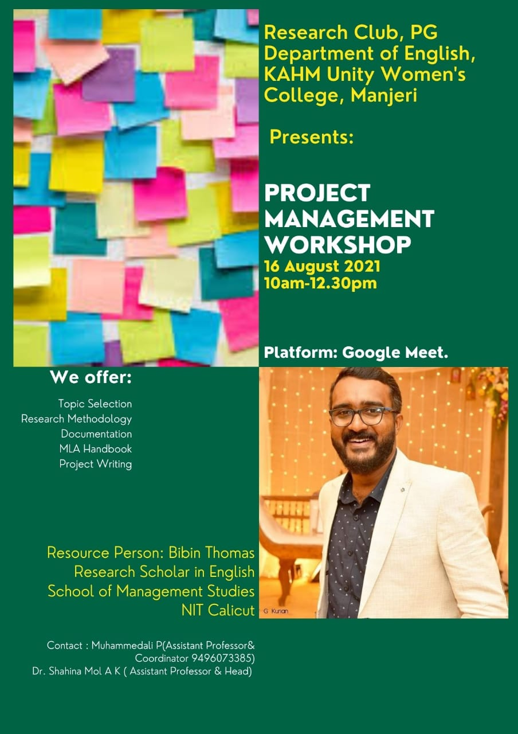

Research Club in collaboration with Research Club, PG Department of English, EMEA College, Kondotty has organized Dialogia Online Lecture Series on “Reading Humanities: Theories and Praxes" with an aim to bridge the gap between numerous developing extents in the purview of humanities and to provide better insights for the faculty members , research scholars, students and other academically driven communities into the fresh domains of humanities disciplines. The inaugural lecture ‘Structure, Sign and Writing: The Texts of Roland Barthes’ was delivered by Mr. Josy Joseph, Associate Professor of English, SB College, Changanassery on 1 October 2021. The second lecture was delivered by Mr. Abdullah Abdul Hameed, Assistant Professor of English, Zakir Hussain Delhi College on the topic ‘Antonio Gramsci, Hegemony and Reading Literature Today: An Introductory Discussion’ on 29 January 2022. The third talk was delivered by Dr. Ashraf Kunnummal, Post-doctoral Research Fellow, Johannesburg, South Africa on the topic ‘Understanding Discourse and Power: A Brief 1ntrodction to Michel Foucault” on 26 February 2022. Students, Teachers and research scholars from various colleges joined for the sessions.

**English Association - Activities 2021-2022:(Inauguration 11August 2022)**

English Association at K.A.H.M Unity Women’s College, Manjeri is a creative endeavour of the enthusiastic learning community of English Department. The major focus of the platform is to function as a catalyst to shape the talents of the students towards perfection. Ms. Khadeeja Nidha of Third Semester BA English and Mr. Sidhique P the faculty member of the department, are the coordinators of the year 2021-2022. The Pandemic scenario troubled the Association activities initially as the team has to envisage new patterns and medium which fulfil the requirements of the programme in the changed context. Selecting Google Meet as the platform for the exchanges, forming a what’s app group of all the class leaders and teachers for this specific purpose and fixing it as a fortnightly event on alternate Wednesdays at 12.30 pm, the crisis was resolved.

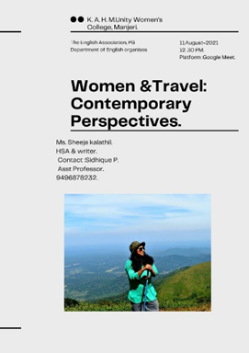

The Inauguration of The English Association 2021-2022 was conducted on 11 August 2021 at 12.30 pm via Google Meet. The Chief Guest was Ms. Sheeja kalathil, HSA & Writer. The chief guest enlightened the audience giving an inspiring talk on Women & Travel: Contemporary Perspectives. The session was anchored by Ms.Khadeeja Nidha,the student coordinator. The programme commenced with welcome address by the faculty coordinator Mr.Sidhique P.A presentation on the various activities carried out and proposed by the English Association, was given by Dr,AK Shahina Mol,HoD of the department. The programme was concluded by 2 PM after the feedback session of the students

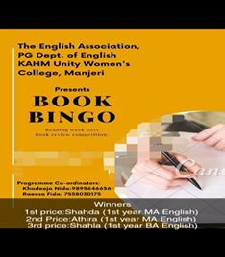

Activity conducted.

|  |  |  |
| --- | --- | --- |
| SL | Name of the Activity | Remarks |
| 1 | Book Bingo, Book Review Competition. | Winners  1.Ms.Shahada ,first year MA English- Bagged first Price.  2.Ms.Athira, first year MA English got Second Price.  3.Ms Shahla First Year Ba English bagged third price |

**UNIVERSE – POETRY PROMOTION PROGRAMME**

As part of poetry promotion, a poetry collection titled, “Scribbles Defying Gravity” (ISBN:978-93-5578-134-5) has been published on behalf of Dept of English under the aegis of Universe- Poetry Reading Platform of the Department. Editors: Ms Aswathi M P, Mr Siddique P. The Book was released on 31 March 2022 by Dr. C. Saidalavi and Captain Dr. A.C. Meera Devi, the senior faculty members of the college.

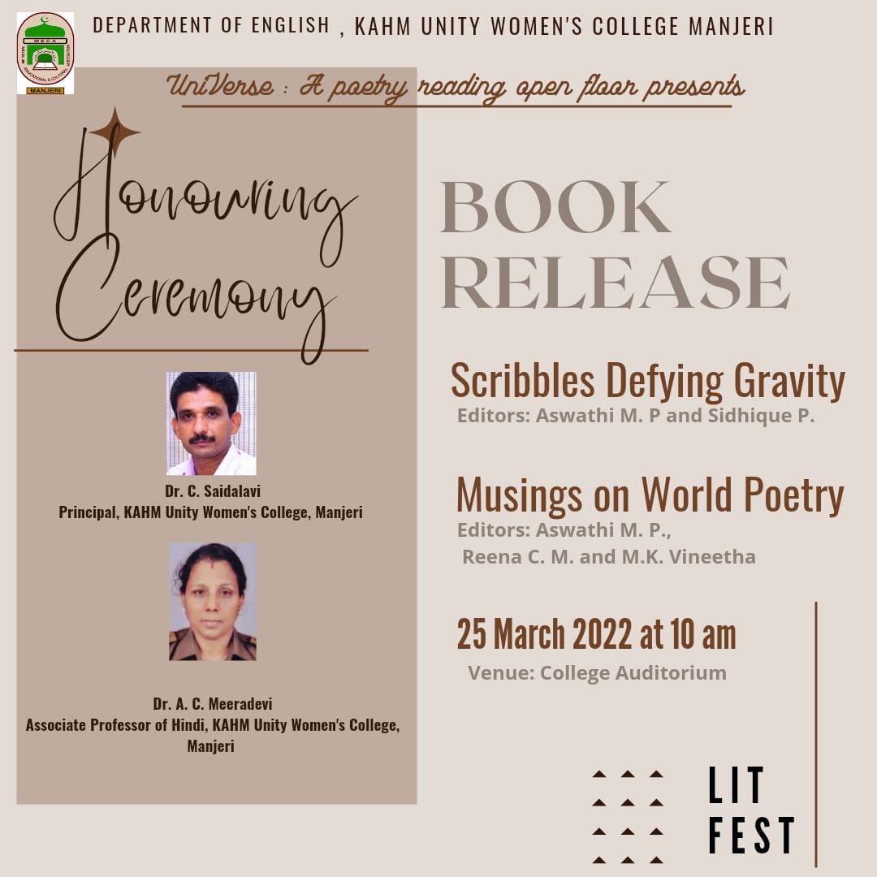

**ALUMNI ENGAGEMENT**: -

Conducted an alumni lecture session on Reading Poetry. Ms Zahira, Research Scholar and Alumni of Dept of English delivered the session on 8 Feb 2022

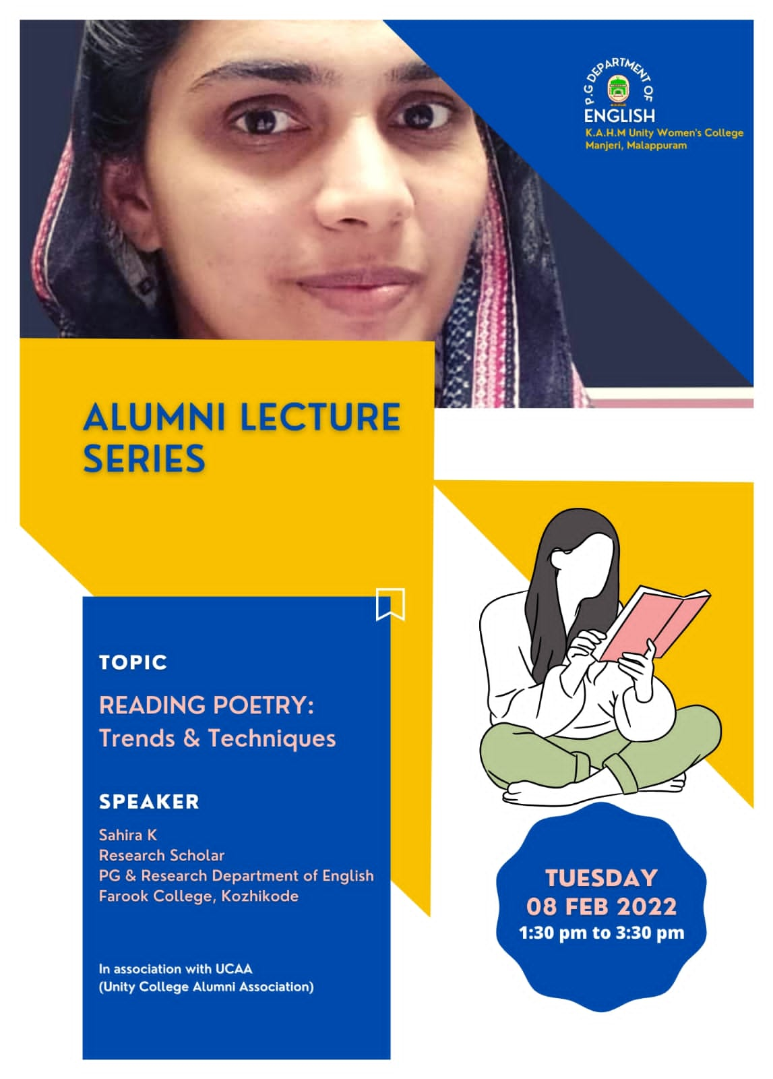

**HONOURING CEREMONY: -**

The honoring ceremony for Class toppers, NET/JRF holders, retiring faculty, PhD holders etc was held on 31 March 2022.