DEPARTMENT OF BOTANY

ANNUAL REPORT

# Staff Members

1. Dr. Usman Arerath; Assistant professor and Head, P.G department of [Botany,usmanarerath@gmail.com,](mailto:Botany%2Cusmanarerath@gmail.com) Mob: 9446973230
2. Dr. Faseela.P; Guest Lecturer, faseela8888@gmail.com,9048226588
3. Dr.Soorya.V; Guest Lecturer, soory.soorya.v18@gmail.com,7510891070
4. Mrs. Shahana Jasmi.A, Guest Lecturer, [shahanajasmi16@gmail.com](mailto:shahanajasmi16@gmail.com), 9847950619
5. Ms. Riya Johnson, Guest Lecturer
6. Ms. Hana Backer ,Guest [Lecturerhanabacker95@gmail.com,](mailto:Lecturerhanabacker95@gmail.com) 9947478140
7. Ashfak Ahammed O, Guest Lecturer, [ashfubot@gmail.com](mailto:ashfubot@gmail.com), 9495567157
8. Dr.Abdul Salam C M Guest Lecturer, [fayisalamcm@gmail.com,](mailto:fayisalamcm@gmail.com) 9446632423

**Department results; 2020 -21**

**B.Sc. Botany**

|  |  |
| --- | --- |
| **Total number of students** | **32** |
| **Total number of students attended** | **32** |
| **Total A+** | **-** |
| **Total A** | **16** |
| **Total B** | **12** |
| **Total C** | **1** |
| **Total D** | **-** |
| **Total E** | **-** |
| **Total F** | **-** |
| **Number of students incompleted** | **3** |

**MSc. BOTANY**

|  |  |
| --- | --- |
| **Total number of students** | **11** |
| **Total number of students attended** | **10** |
| **Total O** | **1** |
| **Total A+** | **7** |
| **Total A** | **3** |
| **Total B+** |  |
| **Total B** |  |
| **Total C+** |  |
| **Total C** |  |
| **Total D** |  |

* College reopened on 1st june 2020 after mid summer vacation, classes were on online mode due to covid 19 issues

#### ASSOCIATION ACTIVITIES

* Activities inaugurated by **Dr. Musthafaanand P.H.;** PSMO College, Thirurangadi He delivered a talk on’**Plants as Immunity Boosters’** on 6th July 2020
* Department conducted a webinar series in the name “**PHYTOS**” and was inaugurated by Dr. Rajesh Kumar. T , NSS College, Manjeri on 8th August 2020. There was an interactive session on **“Plant Taxonomy, Classification and Identification of Angiosperm families”** for UG and PG students.
* Mr.Sabin P Q, Research scholar, presented a webinar on **Career Options In Life Sciences**

for UG and PG students on 15th January 2021 (PHYTOS)

* On 27th January 2021, Dr C.R Elsy , professor and Coordinator, IPR cell, Kerala Agricultural University, interacted with the UG and PG students at the topic**, “Basic Principles of intellectual Property Rights” (PHYTOS)**
* Conducted online interactive sessions on lower plant groups, resource persons and topics are;
  + Dr. Ajayan. K. V – Algal Diversity and its Industrial Uses on 23rd February 2021
  + Dr. Manjula.K.M – Diversity and Importance of bryophytes on 27th February 2021
  + Vijisha.P—Pteridophytes, An introduction on 30th march 2021

#### INSTITUTION/FIELD VISITS

1. Organized a field study trip to *Kerala Forest Research Institute (KFRI)****,*** Kerala Agricultural University (KAU) and *Zoological Park* Wildlife Conservation & Research Centre, *Thrissur* for students of VI Semester B.Sc. (Botany) *on* 3rd March, 2021. There were 30 students 3 staff members in the programme.
2. As part of curriculum, Ist Sem. M.Sc. Botany students (27) went for algal collection to **Thikkodi Coastal Habitat** & visited **Malabar Botanical Garden and Institute for Plant Sciences, Calicut** on 9th February 2021. 5 teachers accompanied them.
3. IVth Sem. M.Sc. Botany students (11) visited **Regional Agricultural Research Station (RARS), *Pattambi, Palakkad*** *on 16th March*, 2021.

#### CERTIFICATE COURSE

* Department conducted a certificate course on Modern Agricultural Technology – MAT (BOT1MAT) for fifth semester UG students of the college. During this year, 9 students successfully completed the course. Course duration was August 2020 – November 2020. Classes were on online mode.

#### DEPARTMENT EXTENSION ACTIVITIES

**1.** Department conducted a workshop on mushroom cultivation in collaboration with Manjeri Municipality, for Kudumbashree members of ward 47, on 20th March 2021. The programme was mainly focused on job oriented training in mushroom cultivation. Total 72 participants including kudumbashree members, students and teachers were participated.

#### BOTANY ASSOCIATION ACTIVITY REPORT 2020-2021

An online meeting of the staff and students of the Botany association in the platform of Google meet was held on June 18th 2020 and Ms. Shibili P.K., III Sem. B Sc Botany was selected as the Association Secretary- in- charge and Dr. Faseela P, as the Association Teacher -in -charge. Dr. Usman A., HOD, Department of Botany put forward the programme schedule of Botany Association in 2020-21 academic year. We decided to conduct the Association inauguration on 6th July 2020 and also a webinar series in the name of ‗PHYTOS‘ on various aspects of Botany.

Botany Association was inaugurated in online mode on 6th July 2020 by Dr. Musthafaanand P.H., HOD, Department of Botany, PSMO College, Thirurangadi. He delivered a talk on ‗Plants as Immunity Boosters‘ to discuss on medicinal properties of plants to overcome the pandemic situation of Covid-19 and around 65 students participated in the programme.

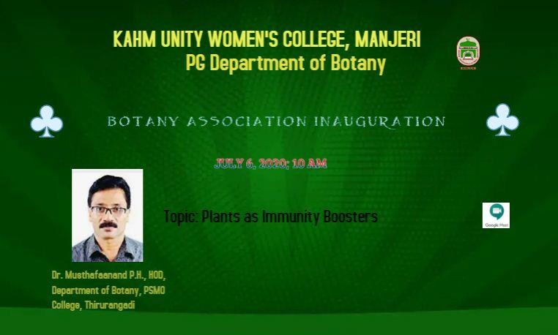

A virtual session on ―Plant Taxonomy, Classification and Identification of Angiosperm families‖ for UG and PG students was conducted under the webinar series ―PHYTOS‖ on 8th August 2020 at 10 AM. The session was handled by Dr. Rajesh Kumar T., Assistant Professor, NSS College, Manjeri and around 99 students participated in the programme.

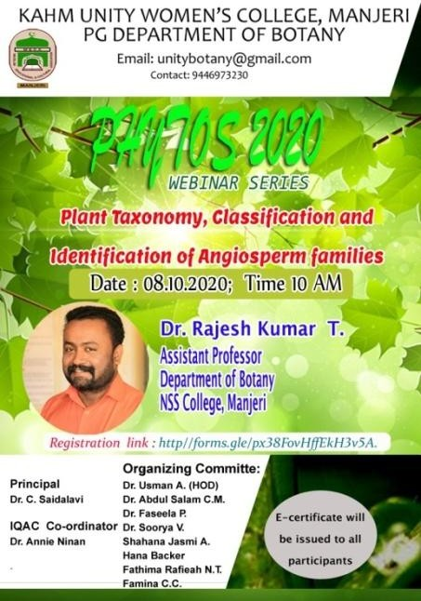

The Association organized an online talk on Career Options in Life Science under the webinar series ‗PHYTOS‘ on 15th January 2021 for PG and UG students. Mr. Sabin P Q, Research scholar, Department of Botany, MES Asmabi College, Thrissur dives into career opportunities of life science and various competitive exams also. He is an effective communicator with a passion in motivating and guiding the students to choose their right career path for a life time success. The webinar was conducted through the Google meet and around 256 students attended the programme.

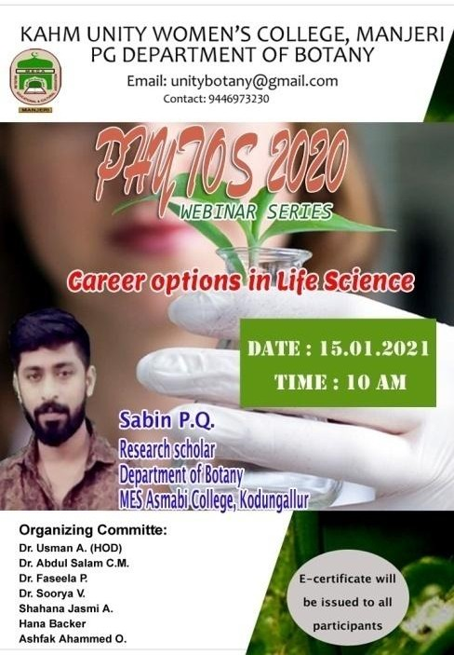

On 27th January 2021, Dr C.R Elsy, professor and Coordinator, IPR cell, Kerala Agricultural University, interacted with the UG and PG students and delivered a virtual session on ―Basic Principles of intellectual Property Rights‖. Over 140 students attended the talk through the online mode and there was an interactive session at the end of webinar. Participants were asked questions and they remarked

that the webinar was very useful to them. She discussed on different aspects of

intellectual properties like industrial design, geographical indication, trade secret, protection of farmers‘ rights and researchers‘ rights, etc.

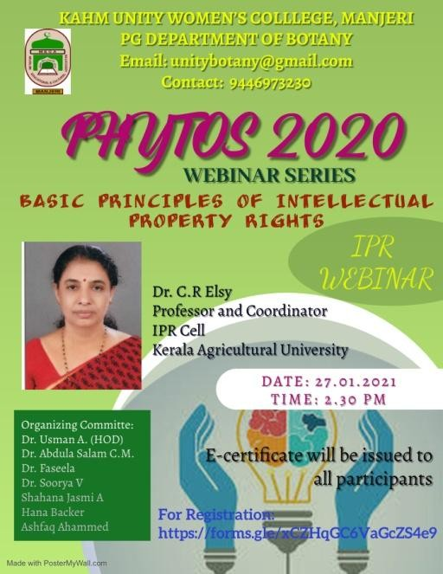

A field trip made to Thikkodi by on 9th February 2021 had the main aim as collecting algae from their natural habitat. The students were thus exposed to the areas where the marine algae could collected. Thikkodi is one among the many unexplode beaches along Kerala's rich sea shore. It is long and wide rocky coast with black clayish sand. The natural rocks & stones provide suitable substratum for algal growth. Different algal species were collected by students from different parts of Thikodi beach such as *Colerpa taxifolia, Colerpa racemosa, Grassilaria, Dyctyota,* etc. The collected algae were preserved for future uses in the laboratory and for other research works.

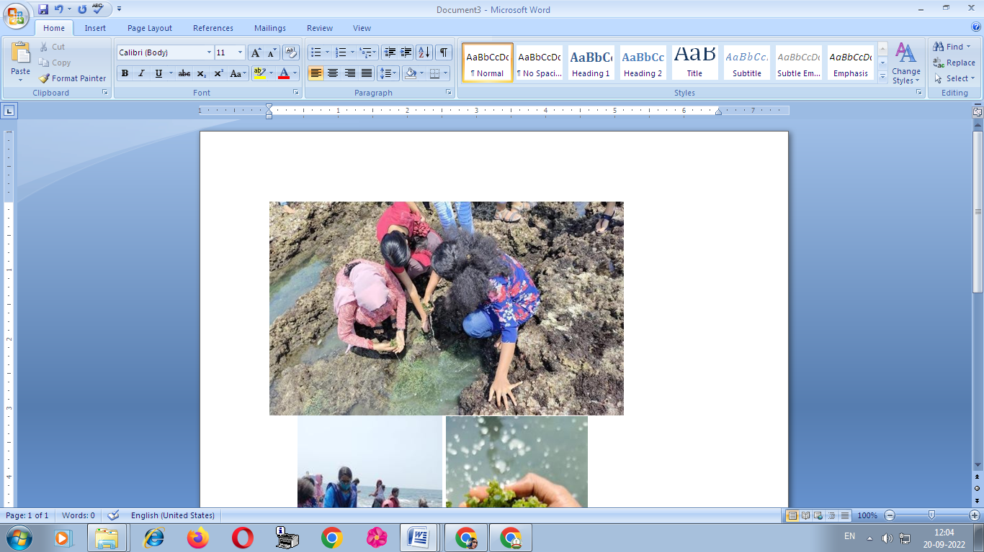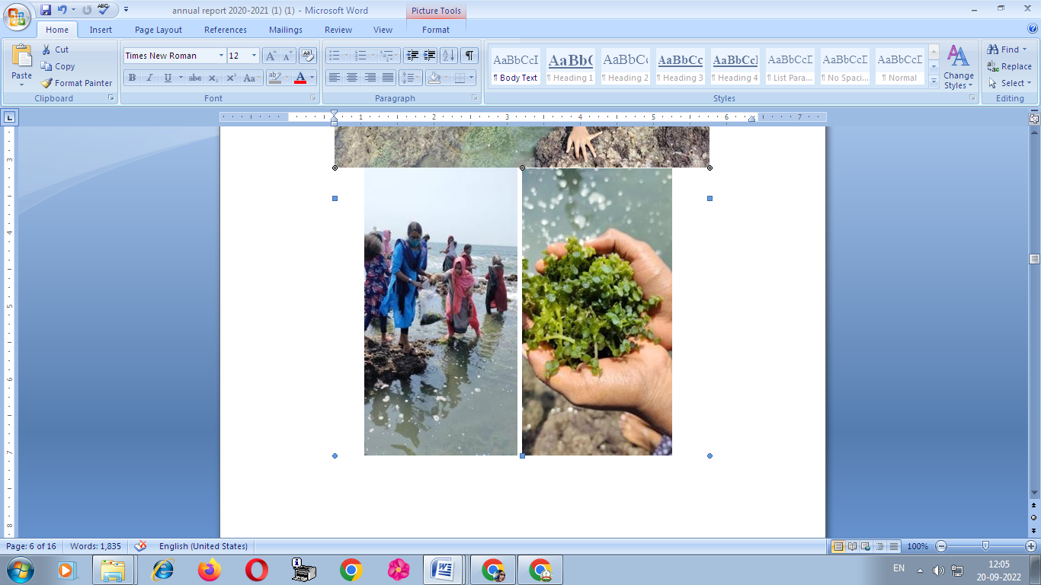

The Botany Association decided to conduct online interactive sessions on lower plant groups; algae, bryophytes and pteridophytes.

Dr. Ajayan. K.V., POST Doc Fellow, Algal biomass laboratory, Environmental Science Division, Department of Botany, University of Calicut delivered a talk on Algal Diversity and its Industrial Uses on 23rd February 2021 at 11 AM on Google meet. About 121 students participated in the webinar and participants learned more about algal products and algae research.

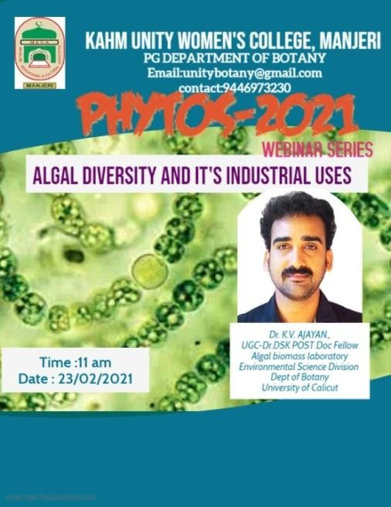

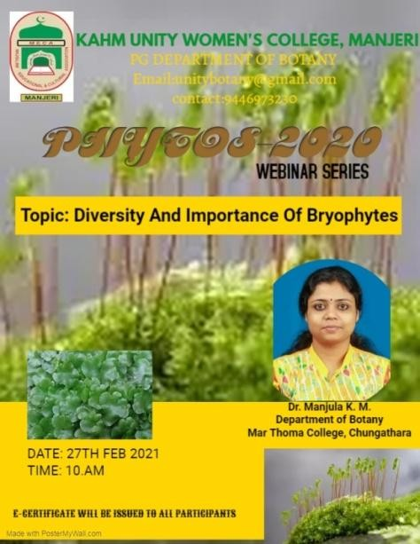An interactive virtual session on Diversity and Importance of bryophytes was delivered by Dr. Manjula K.M., Guest Faculty, Department of Botany, Mar Thoma College, Chugathara on 27th February 2021 at 10 AM. She discussed the bryophyte habitats and their environmental conditions and also to recognize groups of common bryophytes in their natural environments. Over 107 students participated in the session.

The Botany Association conducted a workshop on Mushroom cultivation in collaboration with Manjeri Municipality at PG Department of Botany on 20th March 2021. The workshop was well-attended by the students, teachers in the field of botany and Kudumbashree unit of Ward 47, Manjeri Municipality. About 72 participants were present. The workshop started at 10 a.m. and the welcome speech was delivered by Dr Usman A (HOD PG Department of Botany). Dr. C. Saidalavi (Principal, KAHM Unity Women’s College) gave the presidential address. The presentation and demonstration was done by chief guest Mr. Biju, Mullampara, Manjeri.

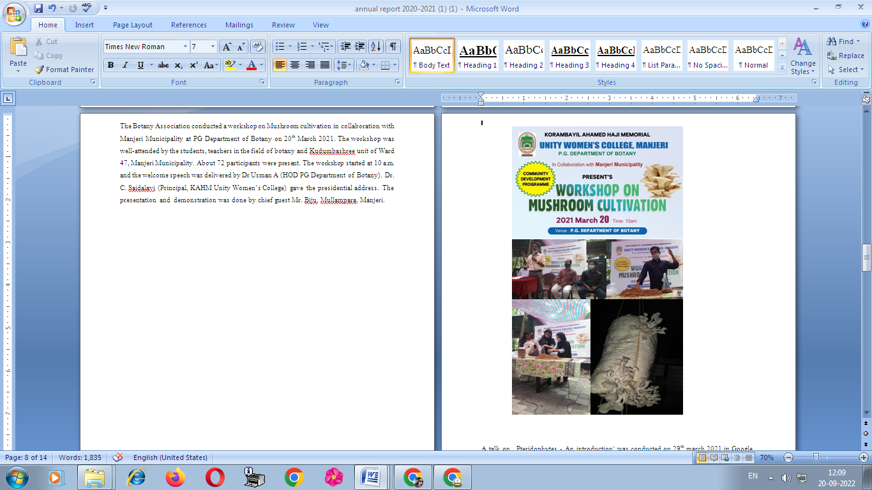

A talk on ‗Pteridophytes - An introduction‘ was conducted on 29th march 2021 in Google meet to explore the world of Pteridophytes. The session was handled by Vijisha, P, Research scholar, The Zamorin‘s Guruvayurappan College, Calicut and over 94 students participated in the programme.

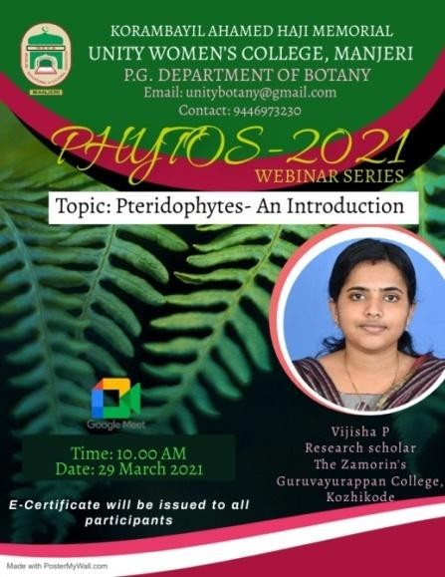

# FIELD TRIPS 2020-2021

### ALGAL COLLECTION TRIP TO THIKKODI

The field study trip made to Thikkodi by MSc students of PG Department of Botany on 09.02.2021 had the main aim as collecting algae from their natural habitat. The students were thus exposed to the areas where the marine algae could be collected. Thikkodi is one among the many unexplored beaches along Kerala's rich sea shore. It is long & wide rocky coast with black clayish sand. The natural rocks & stones provide suitable substratum for algal growth. Different algal species were collected by students from different parts of Thikodi beach such as *Colerpa taxifolia, Colerpa racemosa, Grassilaria, Dyctyota,* etc.

The objectives of the algal collection trip are mentioned as follows:

* Providing knowledge of habitat of particular algae. The algae can either be freshwater habitants or marine. The collection trip gave each and every student who was part of the trip, an idea about the places where sea weeds are found in abundant.
* Exposure to collecting techniques- Proper safety is to be ensured while collecting algae from the sea. The collection is to be done only during the low tide and with proper cautions taken.
* Identification of collected algae- The algae were collected in presence of an efficient algologist who could describe the genus and species name of the collected samples. This enhanced the ability of each and every student to identify an alga even from its natural habitat.
* Knowledge of preservation and herbarium preparation of the collected algae- The collected algae were to be preserved for future uses in the laboratory and for other research works. The preparation of preserving solutions was prepared by the students themselves under guidance of an expert. This gave knowledge about constituents of the solution.

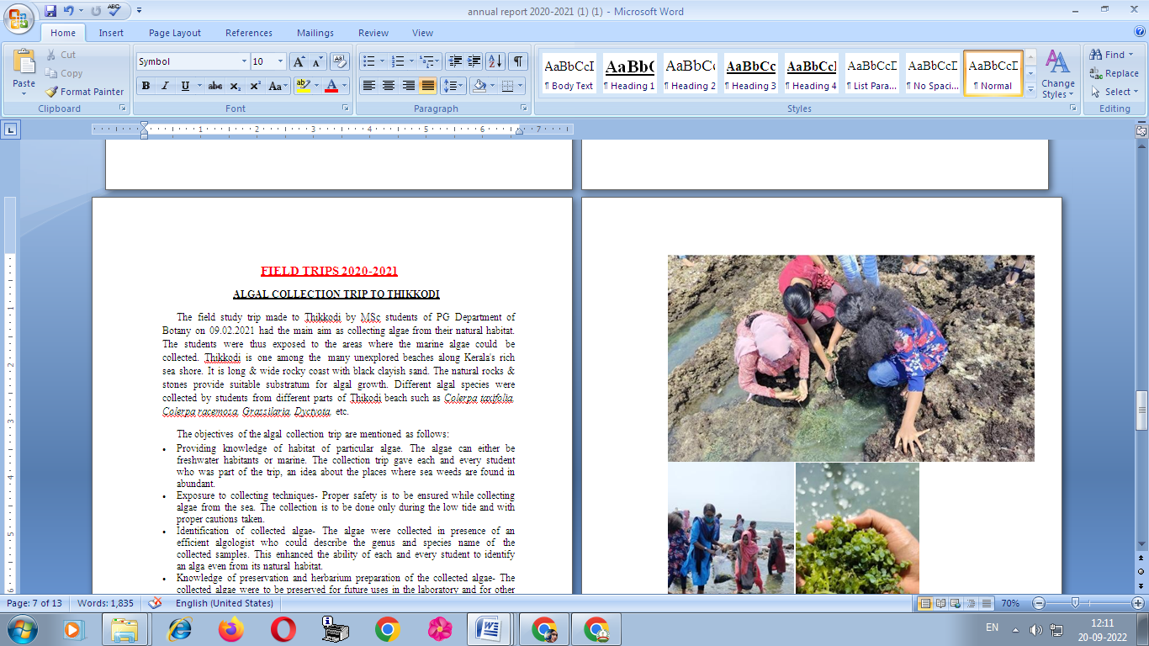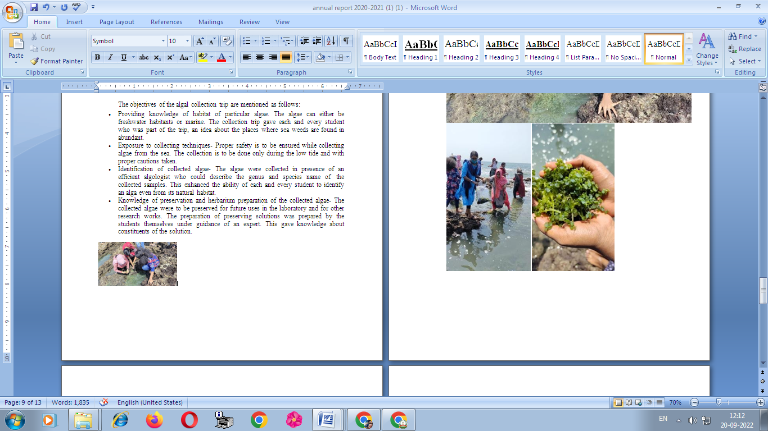

### RESEARCH STATION VISIT TO KFRI, THRISSUR

The research station visit made to KFRI, Thrissur Kerala by BSc students of PG Department of Botany on 03.03.2021 had the main aim as familiarize the various research techniques in the field of forestry. The institute carries out research, training and extension on a range of disciplines related to tropical forests and forestry. The main objective of research institute visit is to provide students an insight of the practical applications of what they are learning in theory because; theoretical knowledge is not enough for making a good professional career. With an aim to go beyond academics, research station visit provides student a practical perspective on the world of work. It provides students with an opportunity to learn practically through interaction and working methods.

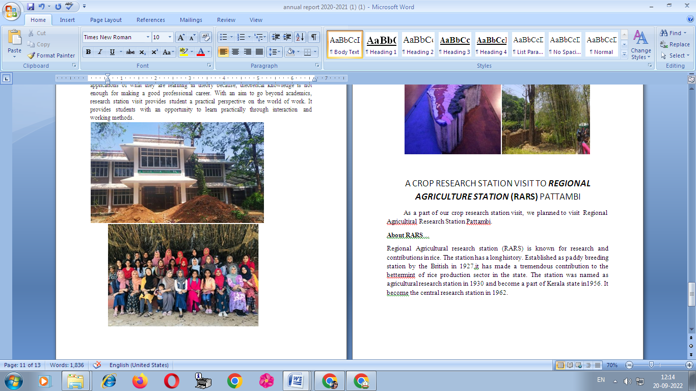

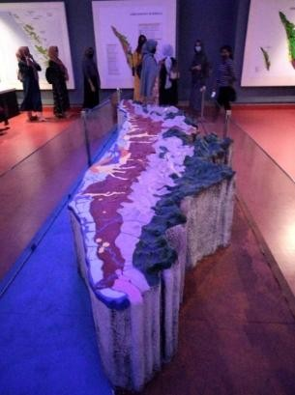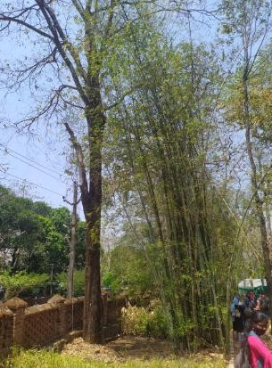

A CROP RESEARCH STATION VISIT TO **REGIONAL AGRICULTURE STATION (RARS)** PATTAMBI

As a part of our crop research station visit, we planned to visit Regional Agricultiral Research Station Pattambi.

**About RARS**…

## Regional Agricultural research station (RARS) is known for research and contributions in rice. The station has a long history. Established as paddy breeding station by the British in 1927,it has made a tremendous contribution to the bettermint of rice production sector in the state. The station was named as agricultural research station in 1930 and become a part of Kerala state in1956. It become the central research station in 1962.